

**A7672X**

**Secondary development hardware design manual**

**LTE Module**



|  |  |
| --- | --- |
| **file name:** | A7672X secondary development hardware design manual |
| **Version:** | V1.01 |
| **date:** | 2021-08-12 |
| **state:** | Published |

**Preface**

This module is mainly used for voice or data communication, and the company does not bear the responsibility for property loss or personal injury caused by the user's abnormal operation. Users are requested to develop corresponding products in accordance with the technical specifications and reference designs in the manual. At the same time, pay attention to the general safety issues that should be paid attention to when using mobile products.

Before making a statement, the company has the right to modify the content of this manual according to the needs of technological development.

# Copyright Notice

This manual contains technical information of SIMCom Wireless Technology (Shanghai) Co., Ltd. (abbreviation: SIMCom). Unless with the written permission of SIMCom, any unit or individual shall not excerpt or copy part or all of the contents of this manual without authorization, and shall not spread it in any form. Violators will be held liable. SIMCom reserves all rights to intellectual property rights such as patents, utility models or designs related to technical information. SIMCom reserves the right to update the specific content of this manual at any time without notice.

The copyright of this manual belongs to SIMCom. Anyone who copies, quotes or modifies this manual without the written consent of our company shall bear legal responsibility.

**SIMCom Wireless Technology (Shanghai) Co., Ltd.**

SIMCom Headquarters Building, Building 3, No. 289 Linhong Road, Changning District, Shanghai

Phone: 86-21-31575100

Email: simcom@simcom.com

Official website: www.simcom.com

**For more information, please click the following link:**

http://cn.simcom.com/download/list-230-cn.html

**For technical support, please click the following link:**

<http://cn.simcom.com/ask/index-cn.html> Or send an email to support@simcom.com

*all rights reserved © SIMCom Wireless Technology (Shanghai) Co., Ltd. 2021, all rights reserved.*

# Version history

|  |  |  |  |
| --- | --- | --- | --- |
| **Date** | **Version** | **Change description** | **author** |
| 2021-04-27 | 1.00 | First edition | Chen Zhongyou, Xia Yu |
| 2021-06-17 | 1.01 | Modify the default level state of GPIO_08 when it is powered on  Modify the description of the serial port  Modify the description of ADC part  Added VDD_AUX adjustable voltage pin description | Chen Zhongyou |
| 2021-07-20 | 1.02 | Modify VDD_AUX adjustable voltage output range  Added GSM frequency band description  Modify the VBAT peak current of the module | Chen Zhongyou, Xia Yu |
| 2021-8-10 | 1.03 | Increase overseas frequency band products | Chen Zhongyou, Xia Yu |

# content

1 Introduction 9

1.1 Module overview 9

1.2 Interface overview 10

1.3 Block diagram 10

1.4 Main features 11

2 Package information 13

2.1 Pin distribution diagram 13

2.2 Pin description 15

2.3 Mechanical dimensions 22

2.4 Recommended PCB package size 23

2.5 Recommended stencil size 24

3 Application interface 26

3.1 Power input 26

3.1.1 Power supply reference design 27

3.1.2 Recommended external power circuit 28

3.1.3 Power monitoring 28

3.2 Power on/off/reset 29

3.2.1 Power on the module 29

3.2.2 Module shutdown 30

3.2.3 Module reset 31

3.3 Serial port 32

3.3.1 Serial reference design 32

3.3.2 RI and DTR description 34

3.4 USB interface 34

3.4.1 USB reference design 34

3.4.2 GPIO_02 (USB_BOOT) interface 35

3.5 USIM card interface 36

3.5.1 USIM reference design 37

3.5.2 Selection of USIM card socket 38

3.6 Analog audio interface 39

3.6.1 Analog Audio Reference Design 40

3.7 Keyboard interface 40

3.8 GPIO interface operation instructions 41

3.9 I2C bus 42

3.10 GNSS function interface 43

3.11 SPI LCD interface 45

3.12 Bluetooth function 46

3.13 Other interfaces 46

3.13.1 Analog-to-digital converter (ADC) 46

3.13.2 LDO 47

4 RF parameters 49

4.1 GSM/LTE RF parameters 49

4.2 GSM/LTE antenna requirements 50

4.3 GNSS radio frequency parameters 51

4.4 GNSS antenna requirements 51

4.5 BlueTooth RF parameters 52

4.6 Antenna reference design 52

4.6.1 GSM/LTE/GNSS/BlueTooth passive antenna 53

4.6.2 GNSS active antenna 53

4.7 PCB trace design 54

5 Electrical parameters 55

5.1 Limit parameters 55

5.2 Normal working conditions 55

5.3 Working mode 56

5.3.1 Working mode definition 56

5.3.2 Sleep Mode 57

5.3.3 Function mode 57

5.4 Current consumption 58

5.5 Electrostatic protection 59

6 Patch production 60

6.1 Top view and bottom view of the module 60

6.2 Label information 61

6.3 Typical welding furnace temperature curve 62

6.4 Moisture Sensitive Characteristics 62

7 Packaging 64

8 appendix 67

8.1 Encoding method and maximum data rate 67

8.2 Reference documents 68

8.3 Terminology and explanation 69

8.4 Safety warning 71

# Table index

Table 1: A7672X module frequency band list 9

Table 2: Main features of the module 11

Table 3: Pin definition list 14

Table 4: Abbreviations of pin parameters 15

Table 5: 1.8V IO pin electrical characteristics 16

Table 6: 3.3V IO pin electrical characteristics 16

Table 7: Pin description 17

Table 8: VBAT pin electrical parameters 26

Table 9: List of recommended TVS tubes 27

Table 10: Power-on sequence parameters 30

Table 11: Shutdown timing parameters 31

Table 12: RESET pin electrical parameters 32

Table 13: GPIO_02(USB_BOOT) description 35

Table 14: USIM interface electrical parameters in 1.8V mode (USIM_VDD=1.8V) 36

Table 15: USIM interface electrical parameters in 3.0V mode (USIM_VDD=3V) 37

Table 16: Amphenol USIM card socket pin description 39

Table 17: Analog audio output (AVDD_AUD=1.8V, T=25°C) 40

Table 18: Keyboard interface pin description 40

Table 19: A7672X standard version software GPIO resources 41

Table 20: GNSS function interface description 43

Table 21: SPI LCD interface description 45

Table 22: General ADC electrical characteristics 46

Table 23: VBAT ADC electrical characteristics 47

Table 24: VDD_1V8 electrical characteristics 48

Table 25: VDD_AUX electrical characteristics 48

Table 26: Conducted emission power 49

Table 27: GSM frequency band information 49

Table 28: 4G frequency band information 49

Table 29: Conduction sensitivity 50

Table 30: 4G Conduction Sensitivity(QPSK)50

Table 31: LTE antenna requirements 50

Table 32: GNSS frequency band 51

Table 33: GNSS performance 51

Table 34: GNSS antenna requirements 51

Table 35: BlueTooth performance 52

Table 36: List of recommended TVS models 53

Table 37: Limit parameters 55

Table 38: Recommended operating voltage of the module 55

Table 39: 1.8V digital interface characteristics 55

Table 40: Module operating temperature 56

Table 41: Working mode definition 56

Table 42: VBAT current consumption(VBAT=3.8V)58

Table 43: ESD performance parameters (temperature: 25°C, humidity: 45%) 59

Table 44: Module information description 61

Table 45: Module humidity sensitivity characteristics 62

Table 46: Pallet size information 65

Table 47: Small cartoon box size information 65

Table 48: Size information of large cartoon box 66

Table 49: Coding method and maximum data rate 67

Table 50: Reference documents 68

Table 51: Terminology and explanation 69

Table 52: Safety warning 71

# Picture index

Figure 1: Module block diagram 11

Figure 2: A7672X module pin diagram (front view)14

Figure 3: Three-dimensional dimensions (unit: mm) twenty two

Figure 4: Recommended PCB package size (unit: mm) twenty three

Figure 5: Recommended stencil size (unit: mm) 25

Figure 6: VBAT drop during a sudden current 26

Figure 7: VBAT input reference circuit 27

Figure 8: Recommended circuit for linear power supply 28

Figure 9: Recommended circuit for switching power supply 28

Figure 10: Reference circuit of switch machine 29

Figure 11: PWRKEY boot sequence 30

Figure 12: PWRKEY shutdown sequence 31

Figure 13: Reset recommended circuit 32

Figure 14: Serial connection diagram 33

Figure 15: Triode level conversion circuit 33

Figure 16: Level change on RI (SMS, URC) 34

Figure 17: USB connection diagram 35

Figure 18: GPIO_02 (USB_BOOT) connection diagram 36

Figure 19: Mandatory download port 36

Figure 20: Recommended circuit for USIM interface 37

Figure 21: Recommended circuit for USIM interface(8PIN)38

Figure 22: Amphenol C707 10M006 512 USIM card socket size drawing 39

Figure 23: Recommended circuit for analog audio interface 40

Figure 24: Keyboard reference design 41

Figure 25: I2C interface reference circuit 43

Figure 26: GNSS reference schematic diagram (non-independent GNSS solution) 44

Figure 27: GNSS reference schematic diagram (independent GNSS solution) 44

Figure 28: SPI LCD interface reference schematic diagram 46

Figure 29: VABT_ADC reference schematic diagram 47

Figure 30: Passive antenna connection circuit 53

Figure 31: Active antenna connection circuit 54

Figure 32: PCB trace reference 54

Figure 33: Top and bottom views of the module 60

Figure 34: Label information 61

Figure 35: Recommended soldering furnace temperature curve (lead-free process) 62

Figure 36: Schematic diagram of module packaging 64

Figure 37: Pallet size drawing 65

Figure 38: Small cartoon box size drawing 65

Figure 39: Dimensions of the large cartoon box 66

# introduction

This document describes the hardware interface of the module, which can help users quickly understand the detailed information of the module's interface definition, electrical performance and structural dimensions. Combining this document and other application documents, users can quickly use the module to design mobile communication applications. SIMCom provides a set of evaluation boards to facilitate the testing and use of A7670 R2 series modules. The evaluation board tools include EVB boards, USB cables, antennas, and other peripherals.

## Module overview

A7672X module can supportLTE-TDD and LTE-FDD.Users can flexibly choose different types of modules to meet diversified market needs. For detailed frequency band description, please refer to the table below:

Table 1: A7672X module frequency band list

|  |  |  |  |  |  |
| --- | --- | --- | --- | --- | --- |
| **Network Type** | **Frequency band** | **A7672E-**  **LASE** | **A7672E-**  **FASE** | **A7672S-**  **LASE** | **A7672S-**  **FASE** |
| GSM | 850 |  |  |  |  |
| 900 | P | P | P | P |
| 1800 | P | P | P | P |
| 1900 |  |  |  |  |
| LTE-FDD | LTE-FDD B1 | P | P | P | P |
| LTE-FDD B2 |  |  |  |  |
| LTE-FDD B3 | P | P | P | P |
| LTE-FDD B4 |  |  |  |  |
| LTE-FDD B5 | P | P | P | P |
| LTE-FDD B7 | P | P |  |  |
| LTE-FDD B8 | P | P | P | P |
| LTE-FDD B20 | P | P |  |  |
| LTE-FDD B28 |  |  |  |  |
| LTE-FDD B66 |  |  |  |  |
| LTE-TDD | LTE TDD B34 |  |  | P | P |
| LTE TDD B38 |  |  | P | P |
| LTE TDD B39 |  |  | P | P |
| LTE TDD B40 |  |  | P | P |
| LTE TDD B41 |  |  | P | P |
| GNSS |  |  | P |  | P |
| BlueTooth |  |  | P |  | P |
| Category |  | CAT1 | CAT1 | CAT1 | CAT1 |

**※pay attention**

|  |
| --- |
| GNSS andBlueToothIt is an optional feature. |

The size of the module is only 24*24*2.4 mm, which can almost meet the space requirements of all M2M applications, such as vehicles, metering, security, routing, wireless POS, mobile computing devices, PDAs, tablet computers, etc.

The A7672X module provides a total of 124 pins, including 80 LCC pins on the outer ring and 44 LGA pins on the inner ring. This article will introduce all the functional pins.

## Interface overview

The A7672X module provides the following hardware interfaces:

●One power input

●One USB 2.0 interface

●Three-way UART interface, a set of full-function serial ports, a set of DEBUG serial ports, a set of two-wire serial ports

●Two-way USIM card interface

●Multiple programmable general-purpose input and output interfaces (GPIO)

●A set of SPI LCD interface (multiplexed)

●A set of 4*4 matrix keyboard interface (multiplexed)

●Universal all the wayADC interface

●One VBAT ADC interface

●Analog audio MIC input interface

●Analog audio SPK output interface

●One SPI interface

●Two-way power supply output

●One I2C interface

●All the way USB_BOOT download boot interface

●Three-way antenna interface

## Block diagram

The following figure shows the main functional structure of the module:



picture1：Module block diagram

## Main features

Table 2：The main features of the module

|  |  |
| --- | --- |
| **characteristic** | **instruction** |
| powered by | voltage range:3.4V~4.2V, recommended value 3.8V |
| Sleep power consumption | Current consumption in sleep mode: <3mA |
| Frequency band | Please refer to the table 1 |
| Transmit power | GSM/GPRS power level:  --EGSM900: 4 (33dBm±2dB)  --DCS1800: 1 (30dBm±2dB)  EDGE power level:  - EGSM900: E2 (27dBm±3dB)  - DCS1800: E1 (26dBm+3dB/-4dB)  LTE power level 3 (23dBm±2.7dB) |
| data transmission | GPRS multi-slot class 12  EDGE multi-slot level 12  TDD/FDD-LTE category 1: 10Mbps (downlink), 5 Mbps (uplink) |
| Antenna interface | GSM/LTE antennainterface  GNSS antenna interface (optional)  BlueToothAntenna interface (optional) |
| Short message (SMS) | MT, MO, CB, Text and PDU mode  Short message (SMS) storage device: USIM card, CB does not support saving in USIM card  Support CS domain and PS domain SMS |
| USIM card interface | Supported 1.8V/3V USIM card |
| USIM Application Toolkit | Support SAT level 3, GSM 11.14 version 99  support USAT |
| Address book management | SM/FD/ON/AP/SDN |
| audio port | Support one analog audio interface |
| Serial port | ●Main serial port UART  Baud rate support from 300bps to 3686400bps  AT commands and data can be sent through the serial port  Support RTS/CTS hardware flow control  Support serial port multiplexing function in line with GSM 07.10 protocol  ●Serial UART_LOG  Support Debug purpose  ●Serial UART3  Ordinary two-wire serial port |
| USB interface | Comply with USB 2.0 specification, support slave mode, not master mode  Can be used for AT command sending, data transmission, software debugging and upgrading |
| software upgrade | Upgrade software via USB port |
| Physical size | Size: 24*24*2.4mm  Weight: 2.8±0.1g |
| temperature range | Working temperature: -30°C~ +80°C  Extended working temperature: -40°C~ +85°C*  Storage temperature: -45°C~ +90°C |

**※pay attention**

|  |
| --- |
| In the extended operating temperature range, the module can work normally, but it is not guaranteed to fully comply with the 3GPP test specifications. |

# Package information

## Pin layout

The pin distribution of the top view of the A7672X module is as follows:



picture2：A7672X module pin diagram (front view)

Table 3：Pin definition list

|  |  |  |  |
| --- | --- | --- | --- |
| Pin number | Pin name | Pin number | Pin name |
| 1 | PWRKEY | 2 | GND |
| 3 | AP_WAKEUP | 4 | GPIO_00 |
| 5 | GPIO_01 | 6 | GPIO_02● |
| 7 | GPIO_03 | 8 | GPIO_04 |
| 9 | TXD | 10 | RXD |
| 11 | SPI_CLK | 12 | SPI_CS |
| 13 | SPI_MOSI | 14 | SPI_MISO |
| 15 | VDD _1V8 | 16 | RESET |
| 17 | GND | 18 | GND |
| 19 | GPIO_05 | 20 | GNSS_PWR_EN/MK_IN_3 |
| 21 | GPIO_07/ MK_OUT_3 | 22 | UART_LOG_RX |
| 23 | UART_LOG_TX | 24 | VBUS |
| 25 | ADC | 26 | GPIO_17 |
| 27 | USB_DP | 28 | USB_DM |
| 29 | GND | 30 | USIM1_VDD |
| 31 | USIM1_DATA | 32 | USIM1_CLK |
| 33 | USIM1_RST | 34 | USIM1_DET |
| 35 | GPIO_13/ MK_OUT_6 | 36 | GPIO_14/ MK_IN_6 |
| 37 | I2C_SDA | 38 | I2C_SCL |
| 39 | GND | 40 | EAR_P |
| 41 | EAR_N | 42 | MIC_P |
| 43 | MIC_N | 44 | GPIO_15/ MK_OUT_2 |
| 45 | GND | 46 | GND |
| 47 | GPIO_16/ MK_IN_2 | 48 | GPIO_08 |
| 49 | UART3_RXD | 50 | UART3_TXD |
| 51 | VBAT_ADC | 52 | GPIO_09 |
| 53 | GPIO_18 | 54 | GND |
| 55 | VBAT | 56 | VBAT |
| 57 | VBAT | 58 | GND |
| 59 | GND | 60 | RF_ANT |
| 61 | GND | 62 | GND |
| 63 | GND | 64 | GND |
| 65 | GND | 66 | GPIO_10 |
| 67 | GPIO_11/ MK_OUT_5 | 68 | GPIO_12/ MK_IN_5 |
| 69 | GND | 70 | GND |
| 71 | GND | 72 | GND |
| 73 | GND | 74 | GND |
| 75 | GND | 76 | GND |
| 77 | GND | 78 | GND |
| 79 | GND | 80 | GND |
| 81 | GND | 82 | GND |
| 83 | GND | 84 | GND |
| 85 | GND | 86 | GND |
| 87 | GND | 88 | GND |
| 89 | GND | 90 | GNSS_ANT |
| 91 | GND | 92 | GND |
| 93 | BT_ANT | 94 | GND |
| 95 | GNSS_TXD | 96 | GNSS_RXD |
| 97 | 1V8_GNSS | 98 | GNSS_PWRCTL |
| 99 | VDD_AUX | 100 | 1PPS |
| 101 | GPIO_19/LCD_BL_PWM | 102 | GPIO_20/LCD_SPI_CLK |
| 103 | GPIO_21/LCD_SPI_TXD | 104 | GPIO_22/LCD_SPI_RXD |
| 105 | GPIO_23/LCD_SPI_CS | 106 | GPIO_24/LCD_RST |
| 107 | GPIO_25/LCD_DCX | 108 | USIM2_DATA |
| 109 | USIM2_CLK | 110 | USIM2_VDD |
| 111 | USIM2_RST | 112 | USIM2_DET |
| 113 | NC | 114 | NC |
| 115 | NC | 116 | GNSS_VBKP |
| 117 | GPIO_26 | 118 | GPIO_27 |
| 119 | GPIO_28 | 120 | GPIO_29 |
| 121 | GPIO_30 | 122 | GPIO_31 |
| 123 | GPIO_32 | 124 | GPIO_33 |

**※pay attention**

|  |
| --- |
| ●It means that these signals cannot be pulled down before power on, otherwise it will affect the normal power on of the module. |

## Pin description

Table 4: Abbreviation of pin parameter

|  |  |
| --- | --- |
| **abbreviation** | **describe** |
| PI | power input |
| PO | Power Output |
| AI | Analog input |
| AO | Analog output |
| I/O | Input or output |
| DI | Digital input |
| DO | Digital output |
| DOH | Default output high level |
| DOL | Default output low level |
| PU | pull up |
| PD | drop down |
| OD | Open drain |

Table 5：1.8V IO pin electrical characteristics

|  |  |  |  |  |  |
| --- | --- | --- | --- | --- | --- |
| **Pin voltage domain attributes** | **abbreviation** | **describe** | **Minimum** | **Typical value** | **Max** |
| 1.8V | DC input conditions (VCC=1.8V) | | | | |
| VIH | Input effective high level | VCC * 0.7 | 1.8V | VCC+0.2 |
| VIL | Input valid low level | -0.3V | 0V | VCC *0.3 |
| Rpu | Module internal pull-up resistor | 55K | 79 K | 121K |
| Rpd | Module internal pull-down resistor | 51K | 87 K | 169K |
| DC input conditions (VCC = 1.8V Typical) | | | | |
| IIL | Input leakage current | - | - | 10uA |
| DC output conditions (VCC = 1.8V Typical) | | | | |
| VOH | Output level range | VCC-0.2 | - | - |
| VOL | Output level range | - | - | 0.2V |
| lol | Low-level output current  Vpad=0.2V | - | - | 13mA |
| loh | High level output current  Vpad=VCC-0.2V | - | - | 11mA |

Table 6：3.3V IO pin electrical characteristics

|  |  |  |  |  |  |
| --- | --- | --- | --- | --- | --- |
| **Pin voltage domain attributes** | **abbreviation** | **describe** | **Minimum** | **Typical value** | **Max** |
| 3.3V | VIH | Input effective high level | 2V | - | VCC+0.3 |
| VIL | Input valid low level | -0.3V | 0V | 0.8V |
| Rpu | Module internal pull-up resistor | 26K | 47K | 72K |
| Rpd | Module internal pull-down resistor | 27K | 54K | 267K |
| IIL | Input leakage current | - | - | 10uA |
| VOH | Output level range | 2.4V | - | - |
| VOL | Output level range | - | - | 0.4V |
| lol | Low-level output current  Vpad=0.4V | - | - | 7mA |
| loh | High level output current  Vpad=VCC-0.5V | - | - | 7mA |

Table 7: Pin description

|  |  |  |  |  |  |
| --- | --- | --- | --- | --- | --- |
| **Pin name** | **Pin number** | **Pin attributes** | | **describe** | **Remark** |
| **Voltage domain** | **Types of** |
| **powered by** | | | | | |
| VBAT | 55,56,57 | - | PI | Module power supply input, the input voltage range is from 3.4V to 4.2V, typically 3.8V, and the power supply current requirement can reach 1A. |  |
| VDD_1V8 | 15 | - | PO | The internal 1.8V power output, the maximum output current is 50mA, can not supply power to high-power loads, and can provide power for level conversion circuits, etc. | It can provide 1V8 power supply for GNSS, if not in use, just leave it in the air. |
| VDD_AUX | 99 | - | PO | Adjustable voltage output, default 3V, maximum output current 50mA, can not supply power to high-power loads. | It can provide power for other peripherals, if not in use, just leave it open. |
| GND | 2,17,18,29,39,45,46,  54,58,59,  61,62,63,  64,65,69,  70,71,72,  73,74,75,  76,77,78,  79,80,81,  82,83,84,  85,86,87,  88,89,91,  92,94 | - | - | Grounded |  |
| **System control** | | | | | |
| PWRKEY | 1 | - | DI,PU | Switch machine control input, active low  The power button defaults to high level  VIH: 0.7*VBAT  VIL: 0.3*VBAT | The inside of the PMU has been pulled up through 50K (Typical) VBAT. |
| RESET | 16 | - | DI,PU | Hardware reset control input, active low  VIH: 0.7*VBAT  VIL: 0.3*VBAT | The inside of the PMU has been pulled up through 50K (Typical) VBAT. |
| **USIM interface** | | | | | |
| USIM1_DATA | 31 | 1.8/  3.0V | I/O, PU | USIM bus data, there is a 4.7KΩ resistor inside the module to pull up to USIM1_VDD |  |
| USIM1_RST | 33 | 1.8/  3.0V | I/O, PU | USIM bus reset output |  |
| USIM1_CLK | 32 | 1.8/  3.0V | I/O, PU | USIM bus clock output |  |
| USIM1_VDD | 30 | 1.8/  3.0V | PO | USIM card power output, the output voltage can be dynamically changed according to the type of external card, the maximum output current is 50mA |  |
| USIM1_DET | 34 | 1.8V | DI,PU | The detection pin of USIM1 card can be set to high/low effective by AT command, refer to document [25] |  |
| USIM2_DATA | 108 | 1.8/  3.0V | I/O, PU | The USIM bus data is not pulled up inside the module. Need to use a 4.7K resistor to pull up to USIM2_VDD outside the module |  |
| USIM2_RST | 111 | 1.8/  3.0V | I/O, PU | USIM bus reset output |  |
| USIM2_CLK | 109 | 1.8/  3.0V | I/O, PU | USIM bus clock output |  |
| USIM2_VDD | 110 | 1.8/  3.0V | PO | USIM card power output, the output voltage can be dynamically changed according to the type of external card, the maximum output current is 50mA |  |
| USIM2_DET | 112 | 1.8V | DI, PD | The detection pin of USIM2 card can be set to high/low effective by AT command, refer to document [25] |  |
| **USB interface** | | | | | |
| VBUS | 24 | - | AI | VBUS in-position detection input, high-level effective, the highest effective voltage is 3.0V, the highest identification voltage is 5.2V |  |
| USB_DM | 28 | - | I/O | USB bus differential negative |  |
| USB_DP | 27 | - | I/O | USB bus differential positive |  |
| **Main serial port** | | | | | |
| RXD | 10 | 1.8V | DI | Data reception | If not used, just leave it in the air |
| TXD | 9 | 1.8V | DOH | Data sending |
| **Debug serial port** | | | | | |
| UART_LOG_TXD | 23 | 1.8V | DOH | UART output | It is used as the debug port by default. |
| UART_LOG_RXD | 22 | 1.8V | DI | UART input |
| **Serial 3** | | | | | |
| UART3_TXD | 50 | 1.8V | DOH | UART3 output | If not used, just leave it in the air. |
| UART3_RXD | 49 | 1.8V | DI | UART3 input |
| **I2C interface** | | | | | |
| I2C_SCL | 38 | 1.8V | DO | I2C bus clock output | If not used, just leave it in the air. Need to use external power supply VDD_1.8V power supply (module 15 feet) for pull-up. |
| I2C_SDA | 37 | 1.8V | I/O | I2C bus data input/output |
| **Analog audio interface** | | | | | |
| EAR_P | 40 | 1.8V | AIO | Audio receiver output positive | If not used, just leave it in the air. |
| EAR_N | 41 | 1.8V | AIO | Audio receiver output negative |
| MIC_P | 42 | 1.8V | AIO | Audio microphone input positive |
| MIC_N | 43 | 1.8V | AIO | Audio microphone input negative |
| **General SPI interface** | | | | | |
| SPI_CLK | 11 | 1.8V | I/O, PD | SPI bus clock output | If not used, just leave it in the air. |
| SPI_CS | 12 | 1.8V | I/O, PD | SPI bus chip select signal |
| SPI_MOSI | 13 | 1.8V | DO, PD | SPI bus host output |
| SPI_MISO | 14 | 1.8V | DI, PD | SPI bus host input |
| **Universal input and output interface** | | | | | |
| GPIO_00 | 4 | 1.8V | IO,PU | Universal input/output port | If not used, just leave it in the air. |
| GPIO_01 | 5 | 1.8V | IO,PU | Universal input/output port | If not used, just leave it in the air. |
| GPIO_02● | 6 | 1.8V | IO,PU | Universal input/output port | If not used, just leave it in the air. |
| GPIO_03 | 7 | 1.8V | IO,PU | Universal input/output port | If not used, just leave it in the air. |
| GPIO_04 | 8 | 1.8V | IO,PU | Universal input/output port | If not used, just leave it in the air. |
| GPIO_05 | 19 | 1.8V | IO,PU | Universal input/output port | If not used, just leave it in the air. |
| GPIO_07 | 21 | 1.8V | IO,PU | Universal input/output port | If not used, just leave it in the air. |
| GPIO_08 | 48 | 1.8V | IO,PU | Universal input/output port | If not used, just leave it in the air. |
| GPIO_09 | 52 | 1.8V | IO,PD | Universal input/output port | If not used, just leave it in the air. |
| GPIO_10 | 66 | 1.8V | IO,PD | Universal input/output port | If not used, just leave it in the air. |
| GPIO_11 | 67 | 1.8V | IO,PU | Universal input/output port | If not used, just leave it in the air. |
| GPIO_12 | 68 | 1.8V | IO,PU | Universal input/output port | If not used, just leave it in the air. |
| GPIO_13 | 35 | 1.8V | IO,PD | Universal input/output port | If not used, just leave it in the air. |
| GPIO_14 | 36 | 1.8V | IO,PD | Universal input/output port | If not used, just leave it in the air. |
| GPIO_15 | 44 | 1.8V | IO,PD | Universal input/output port | If not used, just leave it in the air. |
| GPIO_16 | 47 | 1.8V | IO,PD | Universal input/output port | If not used, just leave it in the air. |
| GPIO_17 | 26 | 1.8V | IO,PD | Universal input/output port | If not used, just leave it in the air. |
| GPIO_18 | 53 | 1.8V | IO,PU | Universal input/output port | If not used, just leave it in the air. |
| GPIO_19 | 101 | 1.8V | IO,PD | Universal input/output port | If not used, just leave it in the air. |
| GPIO_20 | 102 | 1.8V | IO,PU | Universal input/output port | If not used, just leave it in the air. |
| GPIO_21 | 103 | 1.8V | IO,PU | Universal input/output port | If not used, just leave it in the air. |
| GPIO_22 | 104 | 1.8V | IO,PU | Universal input/output port | If not used, just leave it in the air. |
| GPIO_23 | 105 | 1.8V | IO,PU | Universal input/output port | If not used, just leave it in the air. |
| GPIO_24 | 106 | 1.8V | IO,PD | Universal input/output port | If not used, just leave it in the air. |
| GPIO_25 | 107 | 1.8V | IO,PU | Universal input/output port | If not used, just leave it in the air. |
| GPIO_26 | 117 | 1.8V | IO,PU | Universal input/output port | If not used, just leave it in the air. |
| GPIO_27 | 118 | 1.8V | IO,PU | Universal input/output port | If not used, just leave it in the air. |
| GPIO_28 | 119 | 1.8V | IO,PD | Universal input/output port | If not used, just leave it in the air. |
| GPIO_29 | 120 | 1.8V | IO,PD | Universal input/output port | If not used, just leave it in the air. |
| GPIO_30 | 121 | 1.8V | IO,PD | Universal input/output port | If not used, just leave it in the air. |
| GPIO_31 | 122 | 1.8V | IO,PD | Universal input/output port | If not used, just leave it in the air. |
| GPIO_32 | 123 | 1.8V | IO,PU | Universal input/output port | If not used, just leave it in the air. |
| GPIO_33 | 124 | 1.8V | IO,PD | Universal input/output port | If not used, just leave it in the air. |
| **GNSS interface** | | | | | |
| GNSS_PWRCTL | 98 | 1.8V | DI | GNSS internal power supply enable | Active high |
| 1V8_GNSS | 97 | - | PI | GNSS power supply input, the input voltage must be guaranteed not less than 1.8V | Can use VDD_1V8 power supply  (Pin 15 of the module) for power supply |
| GNSS_VBKP | 116 | - | PI | GNSS backup power input, input voltage 1.4V~3.6V | If not used, just leave it in the air. |
| 1PPS | 100 | 1.8V | DO | 1PPS pulse signal output | If not used, just leave it in the air. |
| GNSS_RXD | 96 | 1.8V | DI | GNSS serial port reception | Connect to MCU UART_TX.  Or 10K resistor series connection module  UART3_TX (pin 50). |
| GNSS_TXD | 95 | 1.8V | DO | GNSS serial port transmission | Connect to MCU UART_RX.  Or 10K resistor series connection module  UART3_RX (pin 49). |
| **Antenna interface** | | | | | |
| RF_ANT | 60 | - | AIO | Main antenna interface |  |
| GNSS_ANT | 90 | - | AIO | GNSS antenna interface |  |
| BT_ANT | 93 | - | AIO | Bluetooth antenna interface |  |
| **Other function pins** | | | | | |
| ADC | 25 | - | AI | Universal analog to digital converter interface |  |
| VBAT_ADC | 51 | - | AI | VBAT analog-digital converter interface | If not used, just leave it in the air. |

**※pay attention**

|  |
| --- |
| 1. Please reserve test points for GPIO_02 (USB_BOOT), VDD_1V8 and UART_LOG_TX. If there is no USB connector, please reserve test points for USB_VBUS, USB_DP and USB_DM at the same time for firmware upgrade. 2. ●It means that these signals cannot be pulled down before power on, otherwise it will affect the normal power on of the module. |

## Mechanical Dimensions

The following picture describes the package size of the A7672X module.

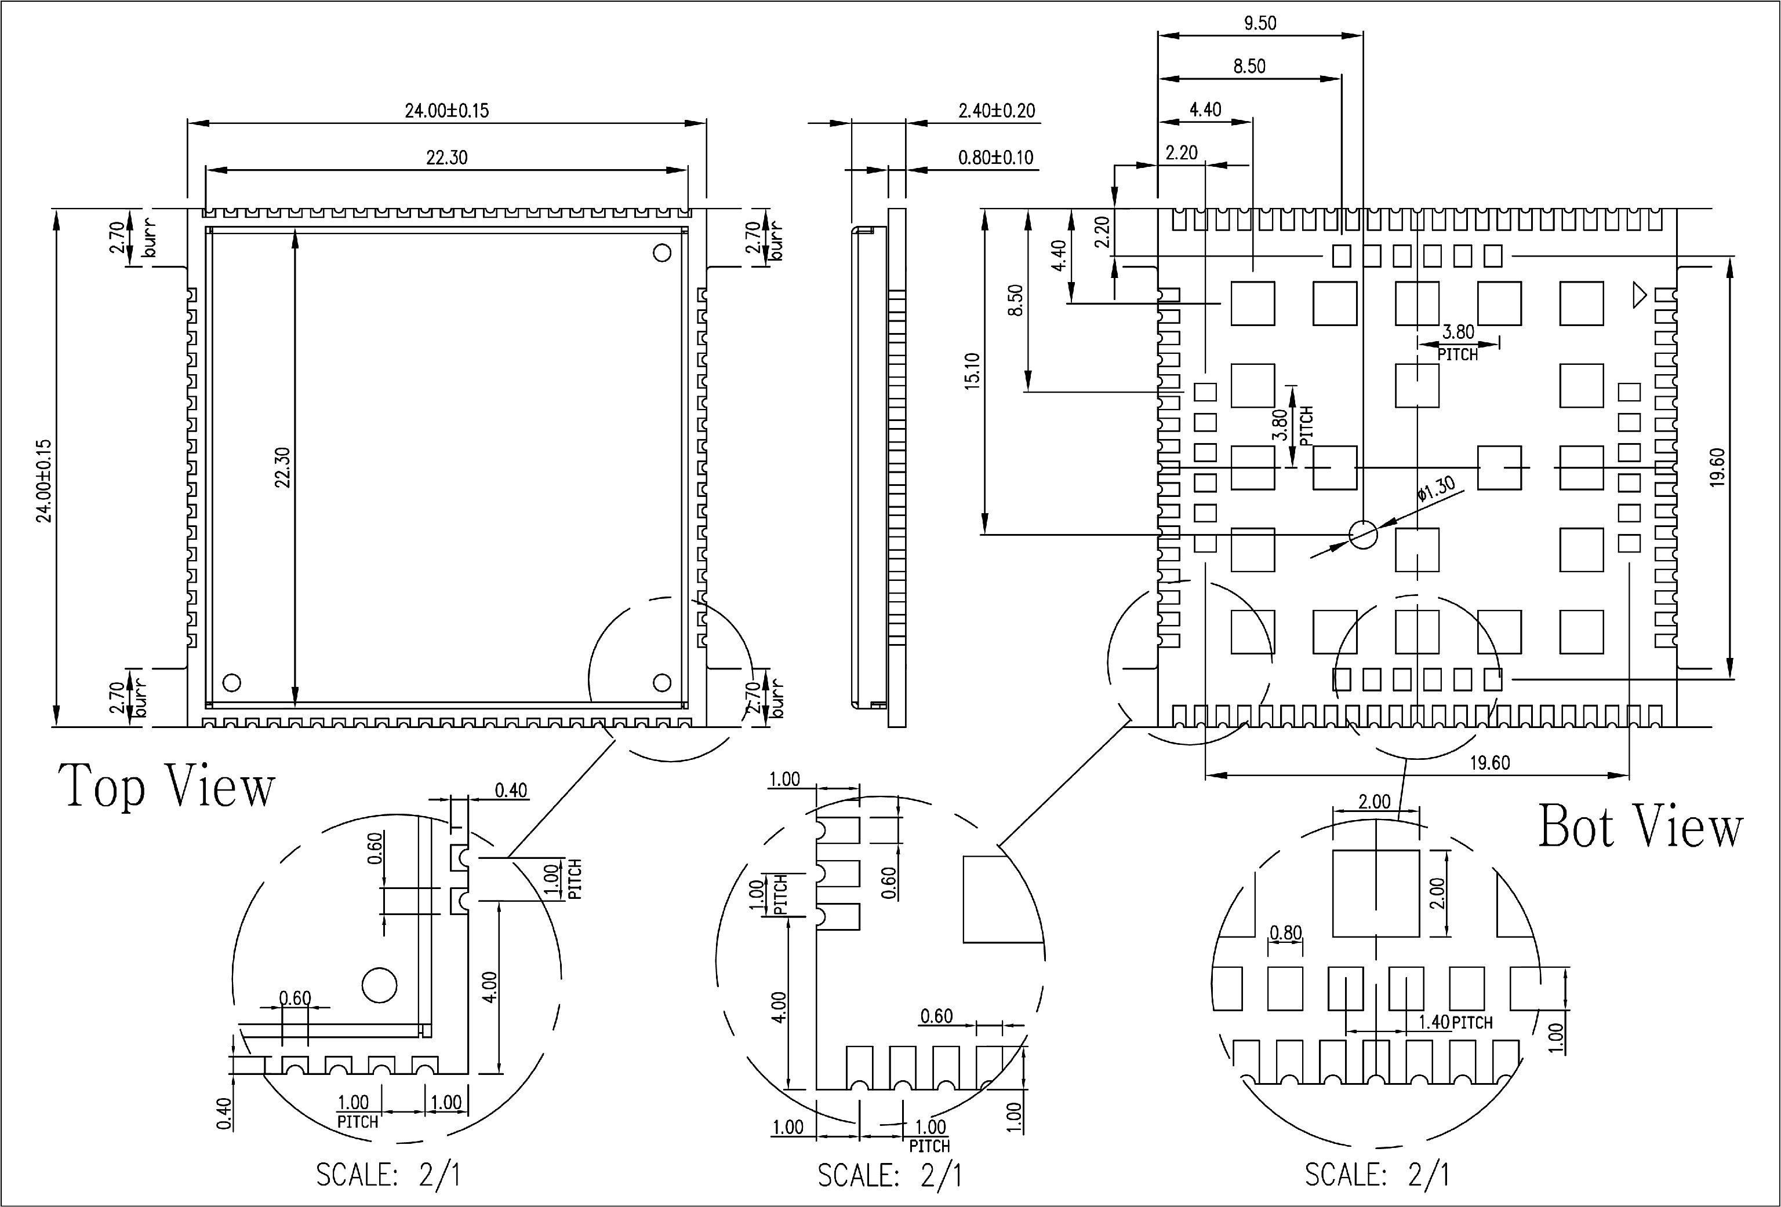

picture3：Three-dimensional size (unit: mm)

**※pay attention**

|  |
| --- |
| The side length dimension 24.00±0.15mm does not include the burr area. |

## Recommended PCB package size

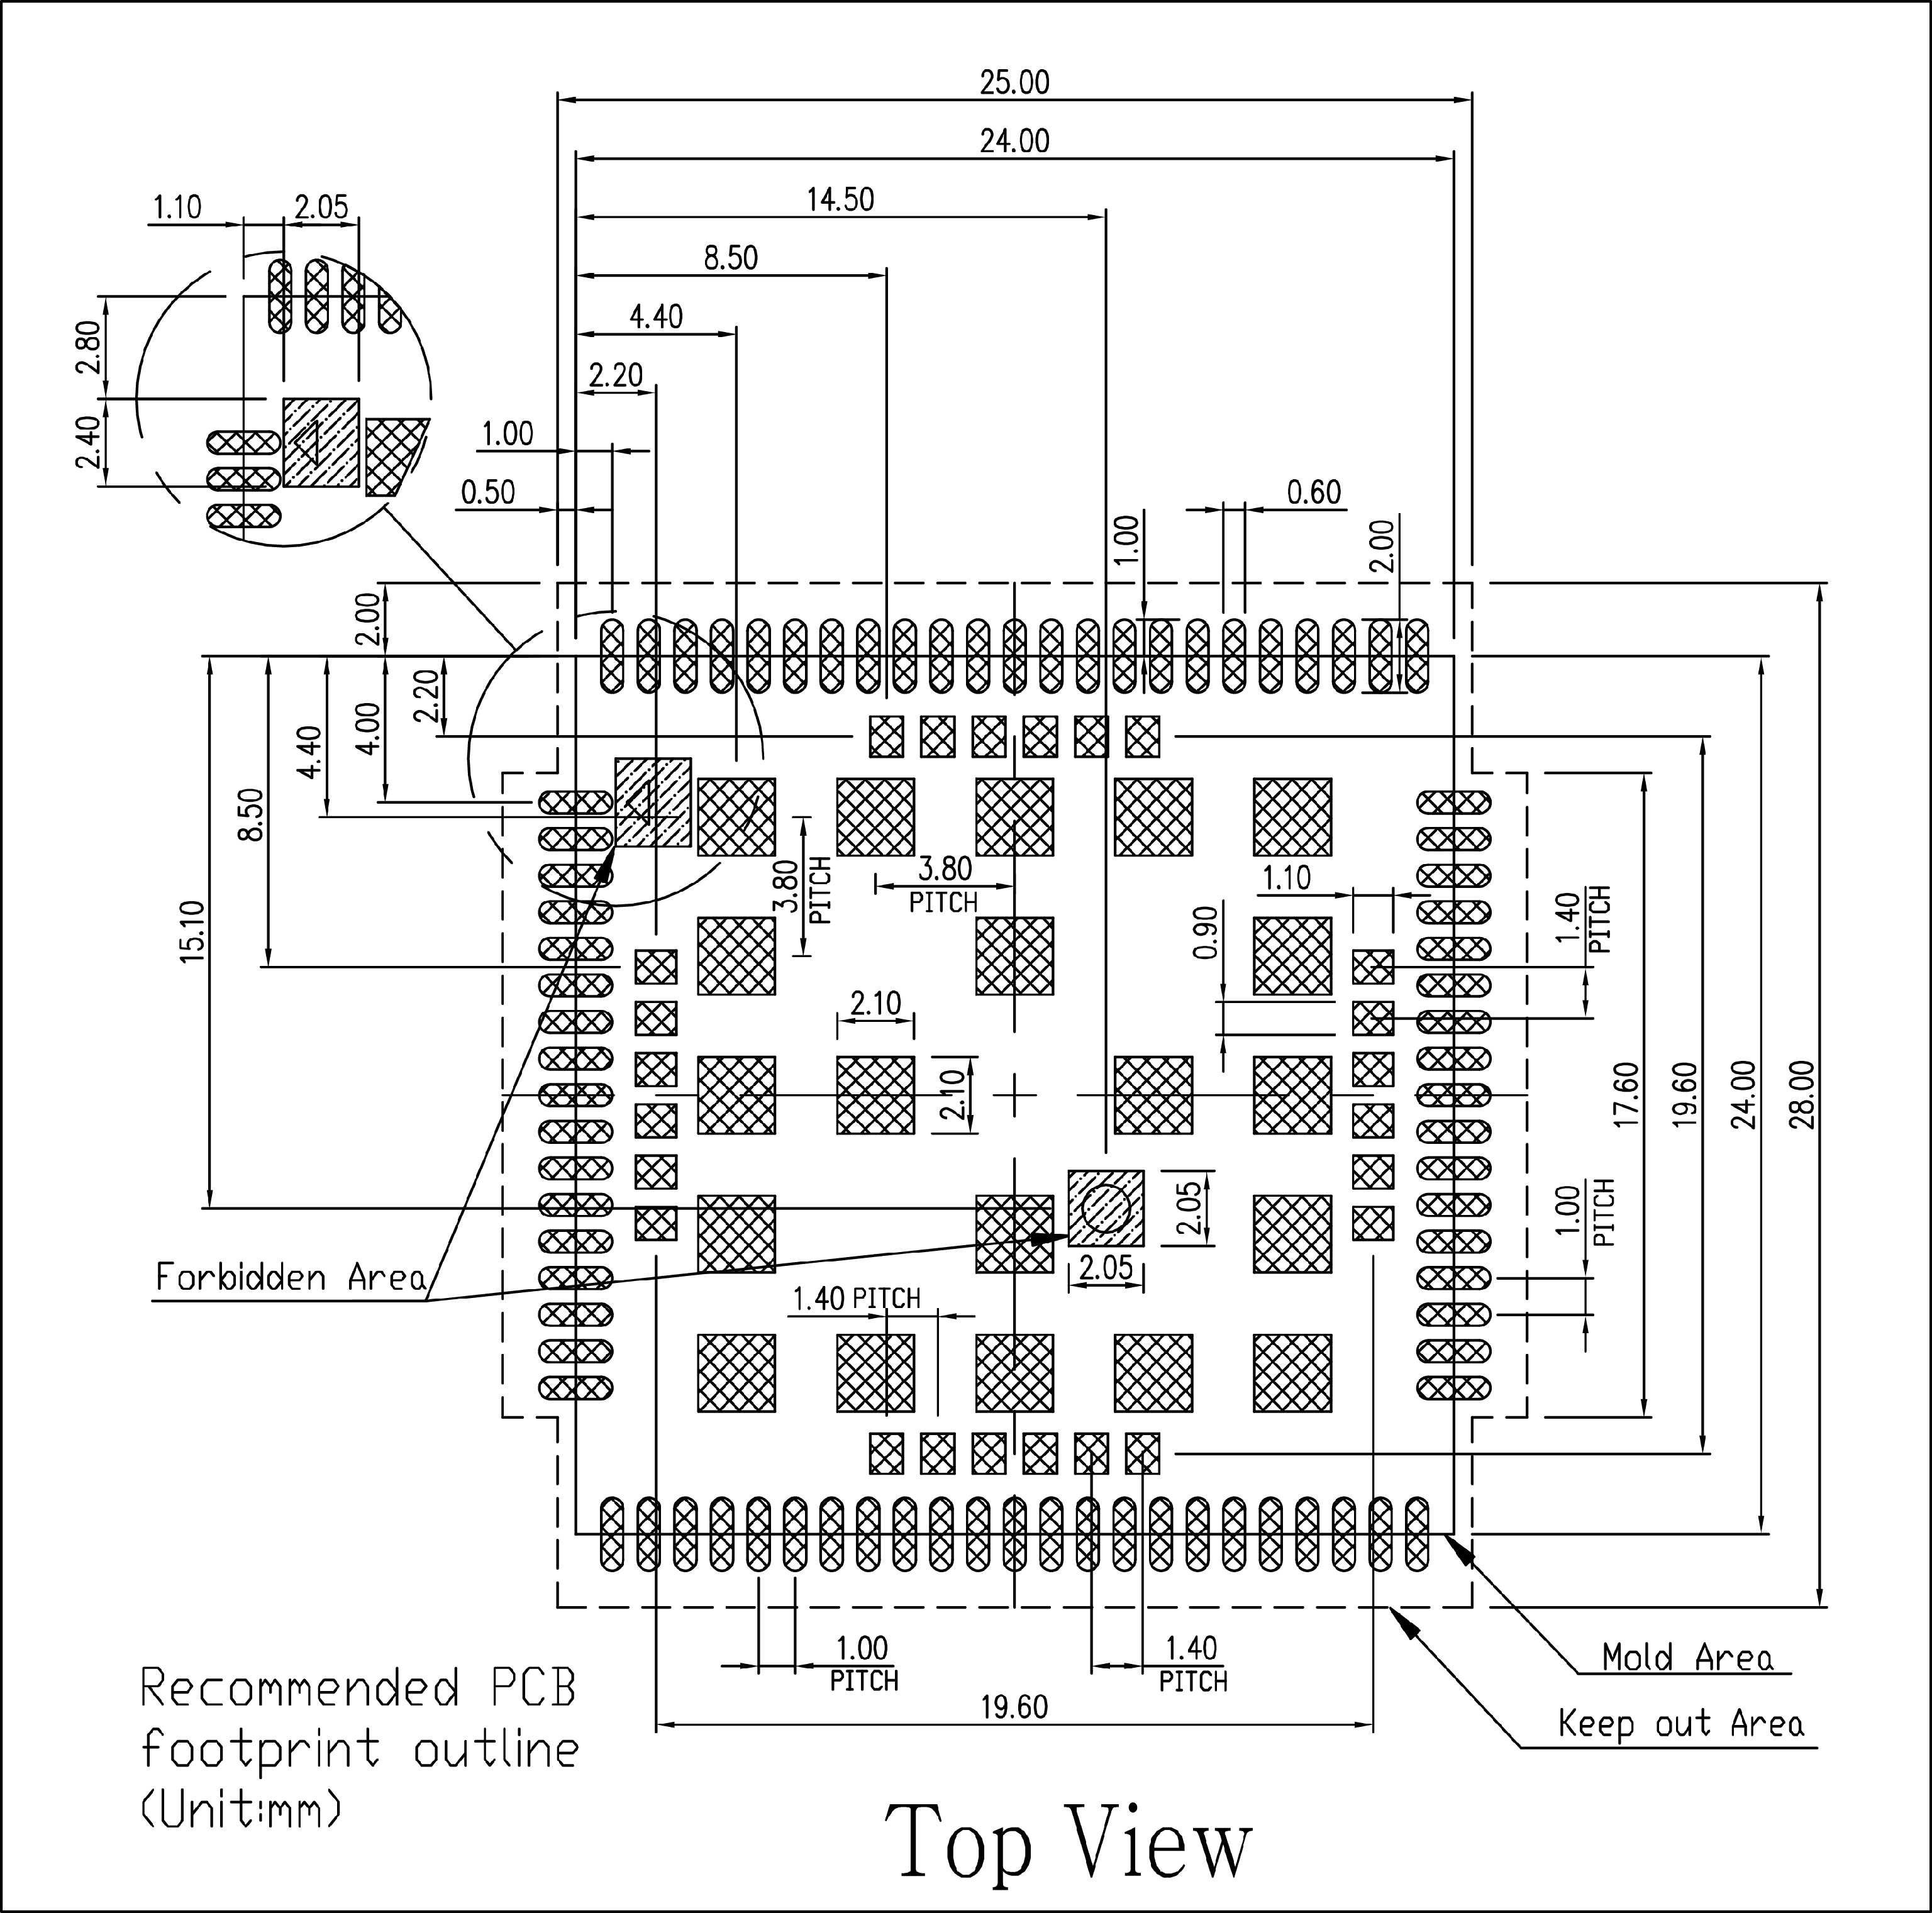

picture4：Recommended PCB package size (unit: mm)

## Recommended stencil size

Recommended steel mesh thickness≧0.12mm,≦0.15mm.

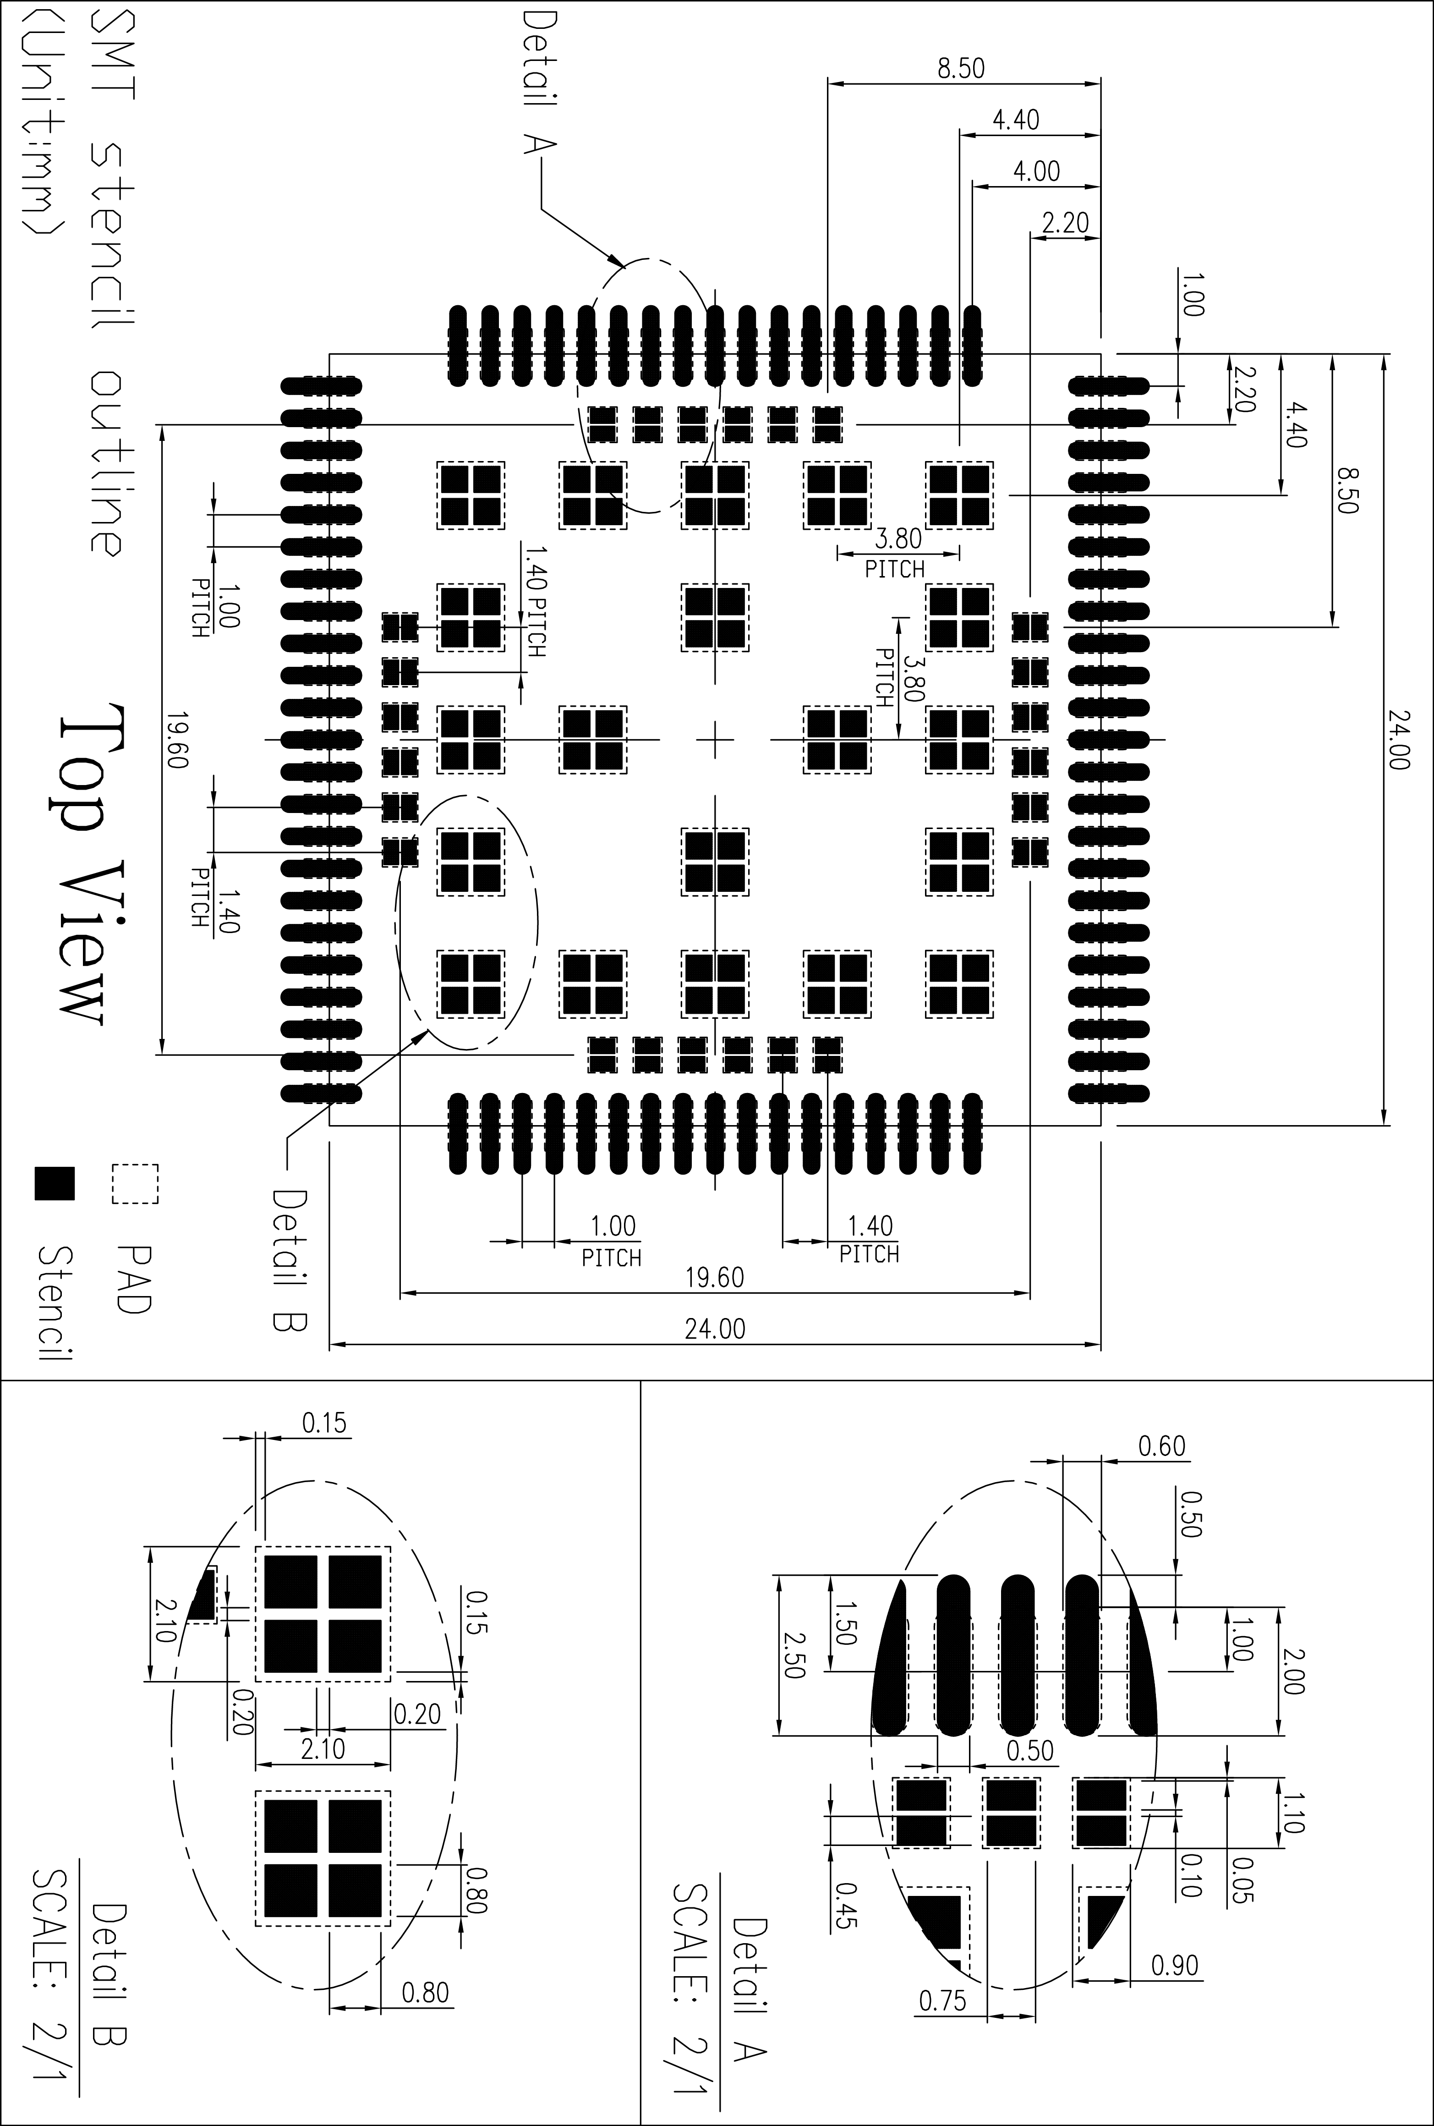

picture5：Recommended steel mesh size (unit: mm)

# Application interface

## Power input

The A7672X module uses a single power supply and has 3 pins (55, 56 and 57 pins) as the VBAT power input. A7672X supplies power to the internal RF and baseband circuits through these 3 pins.

When the module is transmitting at maximum power in GSM mode, the current peak value can reach 2A instantaneously, resulting in a large voltage drop on VBAT. In order to ensure that the voltage drop is less than 300mV, and the power supply voltage is not less than 3.4V during the maximum voltage drop, it is necessary to ensure that the external power supply capability is not less than 2A.

The following figure is a schematic diagram of the voltage drop of VBAT.



picture6：The drop of VBAT during a sudden current

**※pay attention**

|  |
| --- |
| Test conditions: VBAT power supply is 3.8V, and the module is tested with TE board. |

Table 8：VBAT pin electrical parameters

|  |  |  |  |  |  |
| --- | --- | --- | --- | --- | --- |
| **symbol** | **Symbol description** | **The smallest** | **typical** | **maximum** | **unit** |
| VBAT | Module power supply input voltage | 3.4 | 3.8 | 4.2 | V |
| IVBAT(peak) | Peak module current consumption | - | 2 | - | A |
| IVBAT(average) | Average current consumption of the module (normal mode) | Please refer to Table 38 | | | |
| IVBAT(sleep) | Average current consumption of the module (sleep mode) |
| IVBAT(power-off) | Average current consumption of the module (shutdown state) | - | 20 | - | uA |

### Power supply reference design

In the user's design, special attention must be paid to the design of the power supply part. If the voltage drops below 3.4V, the RF performance of the module will be affected. If the voltage is too low, the module will shut down. It is recommended to choose an LDO or DC-DC chip with an enable pin. The enable pin is controlled by the MCU.

**※pay attention**

|  |
| --- |
| It is recommended that the total capacitance of the external capacitor is not less than 300uF to ensure that the voltage drop on the VBAT pin does not exceed 300mV at any time. |

It is recommended to place four ceramic capacitors of 33pf/10pf/0.1/1µF close to VBAT to improve RF performance and system stability. At the same time, it is recommended that the width of the VBAT trace between the power supply on the PCB and the module be at least 3mm. The reference design recommendations are as follows:

If the VBAT input contains high frequency interference, it is recommended to add magnetic beads for filtering. The recommended models of magnetic beads are BLM21PG300SN1D and MPZ2012S221A.

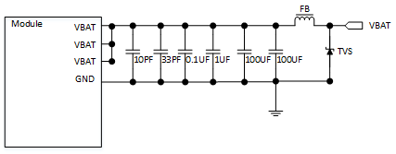

picture7：VBAT input reference circuit

In addition, in order to prevent surge and overvoltage from damaging the A7672X module, it is recommended to connect a TVS tube in parallel to the VBAT pin of the module.

Table 9: List of recommended TVS tubes

|  |  |  |  |  |
| --- | --- | --- | --- | --- |
| **serial number** | **factory** | **Part No** | **Operating Voltage** | **Encapsulation** |
| 1 | Changdian | ESDBW5V0A1 | 5V | DFN1006-2L |
| 3 | Changyuan Wei'an | WS05DPF-B | 5V | DFN1006-2L |
| 4 | Weir | ESD5611N | 5V | DFN1006-2L |
| 5 | Weir | ESD56151W05 | 5V | SOD-323 |

**※pay attention**

|  |
| --- |
| When customers choose TVS by themselves, they need to pay attention to the clamping voltage during surge protection, and the clamping voltage should not be higher than 10V during 100V surge input. |
|  |

### Recommended external power circuit

In the design, the MCU must have the function of powering off the module, but it is prohibited to use the module when it can be shut down or restarted normally. Only when the module fails to shut down or restart normally can the module be powered off. It is recommended to choose an LDO with an enable pin. Or DC-DC chip. When the input power is greater than 9V, it is recommended to use the DCDC chip; when the input is less than 9V, it is recommended to use the LDO power supply. If you use the OPEN LINUX secondary development function of the module, because there is no MCU, you can add a low-cost single-chip microcomputer to play the role of a hardware watchdog that can power on the POWERKEY and power off.

The recommended circuit of linear power supply is shown in the figure below, where PWR_CTRL is the control pin.



picture8：Recommended circuit for linear power supply

The recommended circuit of switching power supply is shown in the figure below, where PWR_CTRL is the control pin:



picture9：Recommended circuit for switching power supply

### Power monitoring

The AT command "AT+CBC" can be used to monitor the VBAT power supply voltage.

The AT command "AT+CVALARM" can set the high/low voltage alarm voltage. When the actual voltage exceeds the preset value range, the warning information will be reported through the AT port.

Use "AT+CPMVT"The high/low voltage shutdown voltage can be set. When the actual voltage exceeds the preset value range, the module will directly shut down automatically.

**※pay attention**

|  |
| --- |
| Power supply voltage monitoring function is being debugged,The over-voltage alarm and over-voltage shutdown functions are turned off by default. For detailed information about related AT commands, please refer to document [1]. |

## Power on/off/reset

### Module boot

The user can turn on the module by pulling down the PWRKEY pin. This pin has been pulled up to VBAT internally in the module.

It is recommended that customers add TVS tubes at the module pins to effectively enhance the anti-static ability of the module when designing. The recommended circuit is as follows:



picture10：Switch machine reference circuit

**※pay attention**

|  |
| --- |
| If the customer does not need to power on automatically, please do not PWRKEY and RESET Parallel over100nF.Otherwise, a low level will be detected when the module is powered on, which will cause the module to automatically turn on. Because PWRKEY and RESET All have the function of pulling down the power-on, which prohibits the power-on process within a short period of time. PWRKEY and RESET, Otherwise it may cause abnormal startup. |



picture11：PWRKEY boot sequence

*Table 10: Power-on timing parameters*

|  |  |  |  |  |  |
| --- | --- | --- | --- | --- | --- |
| **symbol** | **describe** | **Minimum** | **Typical value** | **Max** | **unit** |
| Ton | Power-on low-level pulse width | - | 50 | - | ms |
| Ton(status) | Power-on time (judged according to STATUS pin) | - | 6 | - | s |
| Ton(uart) | Power-on time (judged by UART) | - | 8 | - | s |
| Ton(usb) | Booting time (according to USB judgment) | - | 9 | - | s |
| VIH | PWRKEY pin input high level voltage | 0.7*VBAT | - | VBAT |  |
| VIL | PWRKEY pin input low-level voltage | 0 | 0 | 0.3*VBAT |  |

### Module shutdown

The A7672X module has the following shutdown methods:

* Shut down using PWRKEY pin
* Use "AT+CPOF" command to shut down
* High/low voltage overvoltage shutdown, use "AT+CPMVT"Set the voltage range.
* High and low temperature shutdown

It is strongly recommended that customers use PWRKEY or AT+CPOF to shut down, and then power off VBAT after shutting down (especially when the module does not need to work at all). In addition, it is not possible to shut down by disconnecting VBAT, which may damage FLASH.

**※pay attention**

|  |
| --- |
| When the temperature exceeds -30~+80°CWhen it is in the range, the A7672X module will report warning information through the AT port. When the temperature exceeds -40~+85°CWhen it is in the range, the A7672X module automatically shuts down. "AT+CPOF"And "AT+CPMVT"For detailed description, please refer to document [1]. |

The user can shut down by pulling the PWRKEY signal low. The shutdown sequence diagram is shown in the figure below:



picture12：PWRKEY shutdown sequence

Table 11: Shutdown timing parameters

|  |  |  |  |  |  |
| --- | --- | --- | --- | --- | --- |
| **symbol** | **describe** | **Minimum** | **Typical value** | **Max** | **unit** |
| Toff | Shutdown machine low-level pulse width | 2.5 | - | - | s |
| Toff(status) | Shutdown time (judged according to STATUS pin) | - | 2 | - | s |
| Toff(uart) | Shutdown time (judged by UART) | - | 2 | - | s |
| Toff(usb) | Shutdown time (according to USB judgment) | - | 2 | - | s |
| Toff-on | Shutdown-boot buffer time | 2 | - | - | s |

**※pay attention**

|  |
| --- |
| The STATUS pin can be used to determine whether it is powered on. When the module is powered on and the initialization is complete, STATUS outputs high level, otherwise it keeps low level. |

### ModuleReset

The A7672X module can restart the module by pulling down the RESET pin of the module. The RESET pin also has a low boot function (no computer function). The module only has the boot function when it is powered on for the first time. After booting, the PMU register will be rewritten to disable the boot function of the RESET key. Recommended UsePWRKEY is switched on and off, and RESET is only used as a reset function.

There is already a 50KΩ pull-up resistor inside the module, so there is no need to add a pull-up resistor externally. The recommended circuit is as follows:



picture13：Recommended circuit for reset

Table 12: RESET pin electrical parameters

|  |  |  |  |  |  |
| --- | --- | --- | --- | --- | --- |
| **parameter** | **describe** | **Minimum** | **Typical value** | **Max** | **unit** |
| Treset | Restart low pulse width | 2 | 2.5 | - | S |
| VIH | RESET pin input high level voltage | 0.7*VBAT | - | VBAT | V |
| VIL | RESET pin inputs low-level voltage | 0 | 0 | 0.3*VBAT | V |

**※pay attention**

|  |
| --- |
| It is recommended to use the RESET pin only in emergency situations, such as when the module does not respond. The recommended reset time of RESET is 2.5s. |

## Serial port

The A7672X module provides three serial ports, the main communication serial port UART, the common serial port UART3 and one LOG serial port UART_LOG. The module is a DCE (Data Communication Equipment) device.

### Serial reference design

When using the serial port, you can refer to the following connection method:



picture14：Serial connection diagram

The following figure shows the use of a transistor for circuit conversion. The circuit in the dotted line can refer to the circuit of the solid line TXD and RXD, and you need to pay attention to the direction of the signal. The recommended transistor model here is MMBT3904.



picture15: Triode level conversion circuit

**※pay attention**

|  |
| --- |
| 1.A7672X main serial port UARTThe following baud rates are supported:300, 600, 1200, 2400, 4800, 9600, 19200, 38400, 57600, 115200, 230400, 460800, 921600, 1842000, 3686400.The default baud rate is 115200bps.  2. The maximum baud rate supported by A7672X common serial port UART3 is 921600.  3.Due to the existence of the parasitic capacitance of the triode, it will affect the edge of the high-speed digital signal, and the signal speed is higher than115200bpsIt is not recommended to use this circuit. |

### RIandDTRdescribe

RI usually keeps high level output. When receiving a short message or URC report, RI outputs a low level for 120ms (short message)/60ms (URC), and then returns to a high level state; RI will output a low level. When receiving a phone call as the called party, RI outputs low level. After outputting low level, RI will remain low until the host accepts the call using the "ATA" command or the caller stops calling RI. Restore the output high level.



picture16: Level change on RI (SMS, URC)

DTR can be used as the sleep wake-up pin of the A7672X module. When the A7672X module enters the sleep mode, pull down DTR to wake up the A7672X module.

When the user sets "AT+CSCLK=1"After that, pull the DTR pin high and the module will automatically enter the sleep mode. The serial port function cannot communicate normally at this time. When A7672X enters sleep mode, pull down DTR to wake up the A7672X module.

In the setting "AT+CSCLK=0"In the mode, pull the DTR pin high, there will be no effect, and the normal communication of the serial port function will not be affected.

## USB interface

The A7672X module has a USB2.0 interface, does not support USB charging function, does not support USB HOST mode. Support high speed (480Mbps) and full speed (12Mbps), the interface can be used for AT command transmission, data transmission, software debugging and upgrade. Map out ttyUSB1-ttyUSB2 under linux or android system (refer to linux or android debugging document for details).

USB is the main debugging port and software upgrade interface. It is recommended that customers reserve USB test points during design. If the main control chip is connected, 0R resistors need to be reserved for switching external test points during design.

### USB reference design

The A7672X module can be used as a USB slave device and supports USB sleep and wake-up mechanisms. The recommended connection circuit diagram is as follows:



picture17：USB connection diagram

Customers should pay attention to the selection of the D3 device when using it. It is recommended to choose an anti-static and anti-surge two-in-one device, and a TVS tube can be placed. The recommended model is ESD5681N07.

**※pay attention**

|  |
| --- |
| 1. The USB data line must be routed strictly in 90Ω+/-10% differential form. The TVS devices D1 and D2 on the data line must have an equivalent capacitance value less than 1pF. The TVS device must be placed close to the USB connector or test point. It is recommended Models ESD73011N and WS05DUCFM.  2. The detection and determination of the USB2.0 rate is automatically completed by the USB protocol, and the customer does not need to pull up the DP externally, otherwise it may affect the device USB enumeration. |

### GPIO_02 (USB_BOOT) interface

The module provides a mandatory download boot interface GPIO_02 (USB_BOOT).

Table 13：GPIO_02(USB_BOOT) description

|  |  |  |  |  |  |  |
| --- | --- | --- | --- | --- | --- | --- |
| **Pin number** | **Pin name** | **I/O** | **Function description** | **Voltage domain** | **Default state** | **Remark** |
| 6 | GPIO_02 | DI | Force download boot port | 1.8V | B-PU |  |

If the module cannot be turned on due to abnormal upgrade, you can force the upgrade through the USB_BOOT port.

Before the module is turned on, short-circuit the GPIO_02 pin to GND, then add VBAT power to the module, press RESET, and the module will enter the download mode. After entering the download mode, you need to release GPIO_02 and remove the short circuit.



picture18：GPIO_02 (USB_BOOT) connection diagram

Customers can view the download port in the device manager port of the widows system.

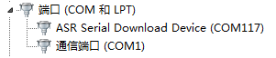

picture19: Mandatory download port

**※pay attention**

|  |
| --- |
| GPIO_02 only has the function of compulsory download and boot before booting (not pull down), and it has other functions after booting. |

## USIM card interface

The A7672X module supports 1.8V and 3.0V USIM cards. The interface power of the USIM card is provided by the voltage regulator inside the module, and the normal voltage is 3V or 1.8V.

Table 14：USIM interface electrical parameters in 1.8V mode (USIM_VDD=1.8V)

|  |  |  |  |  |  |
| --- | --- | --- | --- | --- | --- |
| **symbol** | **describe** | **Minimum** | **Typical value** | **Max** | **unit** |
| USIM_VDD | Power supply voltage output to USIM card | 1.62 | 1.8 | 1.98 | V |
| VIH | Input high level voltage | 0.7*USIM_VDD | - | USIM_VDD +0.4 | V |
| VIL | Input low-level voltage | -0.4 | 0 | 0.25*USIM_VDD | V |
| VOH | Output high level voltage | USIM_VDD -0.4 | - | USIM_VDD | V |
| VOL | Output low-level voltage | 0 | 0 | 0.2 | V |

Table 15：USIM interface electrical parameters in 3.0V mode (USIM_VDD=3V)

|  |  |  |  |  |  |
| --- | --- | --- | --- | --- | --- |
| **symbol** | **describe** | **Minimum** | **Typical value** | **Max** | **unit** |
| USIM_VDD | Power supply voltage output to USIM card | 2.7 | 3 | 3.3 | V |
| VIH | Input high level voltage | 0.7*USIM_VDD | - | USIM_VDD +0.4 | V |
| VIL | Input low-level voltage | -0.4 | 0 | 0.25*USIM_VDD | V |
| VOH | Output high level voltage | USIM_VDD -0.45 | - | USIM_VDD | V |
| VOL | Output low-level voltage | 0 | 0 | 0.3 | V |

### USIM reference design

The following figure is the recommended interface circuit for the USIM card. In order to protect the USIM card, it is recommended to use ST([www.st.com](http://www.st.com/)) The company's ESDA6V15W device or ON SEMI ([www.onsemi.com](http://www.onsemi.com/)) The company's SMF15C device is used for electrostatic protection. The peripheral circuit components of the USIM card should be placed close to the USIM card socket. The recommended circuit of the 8-pin USIM card socket is shown in the figure below.

The reference circuit is shown in the figure below.



picture20：Recommended circuit for USIM interface



picturetwenty one：Recommended circuit for USIM interface (8PIN)

**※pay attention**

|  |
| --- |
| 1. USIM1_DATA has been pulled up to USIM_VDD through a 4.7KΩ resistor, and the external circuit does not need to be pulled up. In addition, the 100nF decoupling capacitor on USIM_VDD is recommended to be retained. For more AT commands about USIM card operation, please refer to document [1]. 2. USIM2_DATA does not have a pull-up resistor, so you need to add a pull-up resistor to USIM2_VDD in the external circuit. |

The USIM card circuit is more susceptible to interference, which may cause the card not to be read or dropped, so please follow the following principles when designing:

* Be sure to keep the USIM card holder away from the main antenna during the PCB layout stage.
* The USIM card wiring should be as far away as possible from RF lines, VBAT and high-speed signal lines, and the USIM card wiring should not be too long.
* The GND of the USIM card socket should maintain good connectivity with the GND of the module, so that the GNDs of the two have the same potential.
* To prevent USIM_CLK from interfering with other signals, it is recommended to protect USIM_CLK separately.
* It is recommended to place a 220nF capacitor on the USIM_VDD signal line close to the USIM card socket.
* Place a TVS close to the USIM card socket. The parasitic capacitance of the TVS should not be greater than 50pF, such as ESD9L5.0ST5G.
* Connecting a 22Ω resistor in series between the USIM card socket and the module can enhance the ESD protection performance.
* In order to make the routing the most smooth, it is recommended to use a single-channel TVS, placed close to each pin of the card socket.
* The USIM_CLK signal is very important. Customers should ensure that the rising edge and falling edge time of the USIM_CLK signal are less than 40ns, otherwise, abnormal card recognition may occur.

### Choice of USIM deck

The 6-pin USIM card holder is recommended to use C707 10M006 512 from Amphenol. Please browse[http://www.amphenol.com](http://www.amphenol.com/)Learn more on the web page!

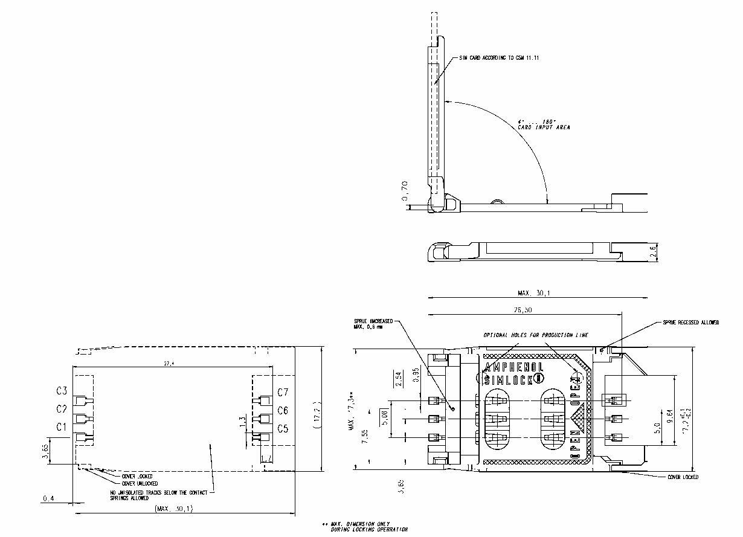

picturetwenty two：Amphenol C707 10M006 512 USIM card socket size drawing

Table 16：Amphenol USIM card socket pin description

|  |  |  |
| --- | --- | --- |
| **Pin name** | **Signal** | **describe** |
| C1 | USIM_VDD | USIM card power supply pin |
| C2 | USIM_RST | USIM card reset pin |
| C3 | USIM_CLK | USIM card clock pin |
| C5 | GND | Grounded |
| C6 | VPP | Not connected |
| C7 | USIM_DATA | USIM card data input/output pin |

**※pay attention**

|  |
| --- |
| If the customer is designing an in-vehicle product, please choose a more reliable USIM card holder. |

## Analog audio interface

A670C R2The module provides a set of analog audio interfaces, integrated audio codec and audio front-end, providing1Analog audioMICInput interface and1Analog audioSPKThe output interface, the customer can make a voice call with an external handle.

ADC: 90dB SNR@20 ~20kHz

DAC: 95dB SNR@20 ~20kHz

(Class-AB): THD< -85dB@32-ohm

Table 17：Analog audio output (AVDD_AUD=1.8V, T=25°C)

|  |  |  |  |  |
| --- | --- | --- | --- | --- |
| parameter | condition | DR (typical value) | THD+N (typical value) | Maximum power |
| ADC | RL=10K | 101dBA | -96dB(@vout -2dBv) | 1.59Vp |
| Class-AB | Mono,32Ω  Difference | 100dBA | -90dB(0.00316%) (@20mW output) | 37mW |

### Analog audio reference design

The recommended circuit for analog audio is shown in the figure below:



picturetwenty three：Recommended circuit for analog audio interface

## Keyboard interface

The module provides a set of 4×4 keyboard interfaces.

Table 18：Keyboard interface pin description

|  |  |  |  |  |
| --- | --- | --- | --- | --- |
| Module PIN name | Reuse function | Pin | I/O | describe |
| GPIO_16 | MK_IN2 | 47 | DI | Keyboard input signal |
| GNSS_PWR_EN | MK_IN3 | 20 | DI |
| GPIO_12 | MK_IN5 | 68 | DI |
| GPIO_14 | MK_IN6 | 36 | DI |
| GPIO_15 | MK_OUT2 | 44 | DO | Keyboard output signal |
| GPIO_07 | MK_OUT3 | twenty one | DO |
| GPIO_11 | MK_OUT5 | 67 | DO |
| GPIO_13 | MK_OUT6 | 35 | DO |

Keyboard interface reference design:

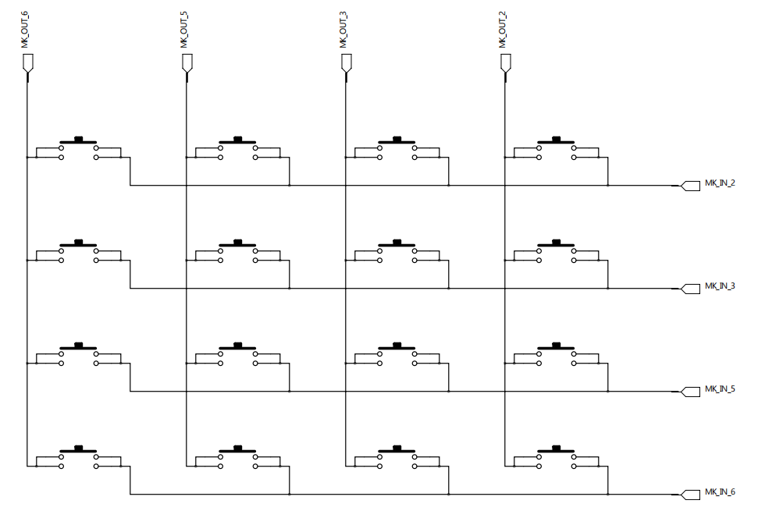

picturetwenty four: Keyboard reference design

## GPIO interface operation instructions

The A7672X module provides customers with multiple GPIO usage.

Table 19：A7672X standard edition software GPIO resources

|  |  |  |  |  |  |  |
| --- | --- | --- | --- | --- | --- | --- |
| **Pin number** | **Pin name** | **Voltage domain** | **Power-on state** | **Default function** | **Reuse function** | **Interrupt function** |
| 4 | GPIO_00 | 1.8V | PU | GPIO |  | support |
| 5 | GPIO_01 | 1.8V | PU | GPIO |  | support |
| 6 | GPIO_02● | 1.8V | PU | GPIO | PWM2 | support |
| 7 | GPIO_03 | 1.8V | PU | GPIO | UART_RTS | support |
| 8 | GPIO_04 | 1.8V | PU | GPIO | UART_CTS | support |
| 19 | GPIO_05 | 1.8V | PU | GPIO |  | support |
| 20 | GNSS_PWR_EN | 1.8V | PD | GPIO | MK_IN_3 | support |
| 21 | GPIO_07 | 1.8V | PU | GPIO | MK_OUT_3 | support |
| 48 | GPIO_08 | 1.8V | PU | GPIO |  | not support |
| 52 | GPIO_09 | 1.8V | PD | GPIO |  | support |
| 66 | GPIO_10 | 1.8V | PD | GPIO | PWM1 | support |
| 67 | GPIO_11 | 1.8V | PU | GPIO | MK_OUT_5 | support |
| 68 | GPIO_12 | 1.8V | PU | GPIO | MK_IN_5 | support |
| 35 | GPIO_13 | 1.8V | PD | GPIO | MK_OUT_6 | support |
| 36 | GPIO_14 | 1.8V | PD | GPIO | MK_IN_6 | support |
| 44 | GPIO_15 | 1.8V | PD | GPIO | MK_OUT_2 | support |
| 47 | GPIO_16 | 1.8V | PD | GPIO | MK_IN_2 | support |
| 26 | GPIO_17 | 1.8V | PD | GPIO |  | support |
| 53 | GPIO_18 | 1.8V | PU | GPIO |  | support |
| 101 | GPIO_19 | 1.8V | PD | GPIO | LCD_BL_PWM | not support |
| 102 | GPIO_20 | 1.8V | PU | GPIO | LCD_SPI_CLK | support |
| 103 | GPIO_21 | 1.8V | PU | GPIO | LCD_SPI_TXD | support |
| 104 | GPIO_22 | 1.8V | PU | GPIO | LCD_SPI_RXD | support |
| 105 | GPIO_23 | 1.8V | PU | GPIO | LCD_SPI_CS | support |
| 106 | GPIO_24 | 1.8V | PD | GPIO | LCD_RST | not support |
| 107 | GPIO_25 | 1.8V | PU | GPIO | LCD_DCX | support |
| 117 | GPIO_26 | 1.8V | PU | GPIO |  | support |
| 118 | GPIO_27 | 1.8V | PU | GPIO |  | support |
| 119 | GPIO_28 | 1.8V | PD | GPIO |  | not support |
| 120 | GPIO_29 | 1.8V | PD | GPIO |  | not support |
| 121 | GPIO_30 | 1.8V | PD | GPIO |  | support |
| 122 | GPIO_31 | 1.8V | PD | GPIO |  | support |
| 123 | GPIO_32 | 1.8V | PU | GPIO |  | support |
| 124 | GPIO_33 | 1.8V | PD | GPIO |  | support |

## I2C bus

The module provides a set of hardware I2C protocol interface, supports standard mode 100Kbps, supports high-speed mode 400Kbps, and the working voltage is 1.8V.

I2C is an open-drain output, and the reference circuit is shown in the figure below:



picture25：I2C interface reference circuit

**※pay attention**

|  |
| --- |
| SCL and SDA pins need pull-up resistors, and the pull-up power must be VDD_1V8 output by the module. |

## GNSS function interface

A7670 R2 is equipped with GNSS function. GNSS provides 2 power supply input interfaces, 1 GNSS power enable control switch, 1 2-wire UART interface and 1 pulse synchronization clock signal interface. The details are as follows.

Table 20: GNSS functional interface description

|  |  |  |  |  |
| --- | --- | --- | --- | --- |
| **PIN name** | **Pin** | **I/O** | **describe** | **Remark** |
| GNSS_VBKP | 116 | PI | GNSS backup power input | The power supply range is 1.4V~3.6V. |
| 1V8_GNSS | 97 | PI | GNSS Vcore, VDDIO power input | The power supply voltage is required to be no less than 1.8V. The trace should be as short as possible, and the line width should be above 0.5mm. |
| GNSS_PWRCTL | 98 | DI | GNSS Vcore, VDDIO power supply enable control switch | Active high.  Solution 1: Connect the module GPIO, it is recommended to use MK_IN_3 (PIN20).  Solution 2: Connect MCU GPIO. |
| GNSS_RXD | 96 | DI | GNSS serial port data reception in the module | 1.8V power domain.  Solution 1: 10K resistor series connection module UART3_TXD (PIN50).  Solution 2: Connect MCU UART_TX. |
| GNSS_TXD | 95 | DO | GNSS serial data transmission in the module | 1.8V power domain.  Solution 1: 10K resistor series connection module UART3_RXD (PIN49).  Solution 2: Connect MCU UART_RX. |
| 1PPS | 100 | DO | GNSS pulse clock synchronization signal | The second pulse signal can be used for precise timing. |

Wiring scheme one:

GNSS byThe non-independent GNSS reference design that the module itself provides power supply, power supply enable, and UART transparent transmission is as follows:



picture26: GNSS reference schematic diagram (non-independent GNSS solution)

Wiring scheme two:

The independent GNSS reference design where the GNSS is powered by the module and transparently transmitted by the MCU UART is as follows. This wiring method is used in scenarios where the GNSS can work independently without the module being turned on:



picture27：GNSS reference schematic diagram (independent GNSS solution)

**※pay attention**

|  |
| --- |
| 1. It is recommended to connect a 10K resistor in series with the serial communication line of the non-independent GNSS solution to prevent the leakage current of the serial port of the GNSS chip. 2. The reference schematic diagram of the independent GNSS solution is only applicable to the 1.8V voltage domain MCU. If the MCU is not in the 1.8V voltage domain, a level conversion circuit needs to be added. 3. The main power input of GNSS, 1V8_GNSS, has higher power requirements. The PCB traces should be as short as possible, and the line width should be at least 0.5mm. |

## SPI LCD interface

The A7672X module provides a set of SPI LCD interface, which only supports 1 data line LCD module. The LCD interface of the module does not have a dedicated LCD_TE signal pin. If necessary, you can choose GPIO to simulate use. It is recommended to use the module's pin 44 (GPIO_15/ MK_OUT_2) is used as the LCD_TE signal.

It is recommended to reserve a voltage stabilizing capacitor and a decoupling capacitor on the LCD power supply line, and reserve a series 0Ω resistor for debugging. At the same time, 0Ω is reserved in series on the data line to facilitate the adjustment of signal quality and prevent signal reflection and overshoot.

surfacetwenty one: SPI LCD interface description

|  |  |  |  |  |
| --- | --- | --- | --- | --- |
| **Module PIN name** | **Reuse function** | **Pin** | **I/O** | **describe** |
| GPIO_19 | LCD_BL_PWM | 101 | DO | LCD backlight PWM adjustment |
| GPIO_20 | LCD_SPI_CLK | 102 | DO | SPI clock signal |
| GPIO_21 | LCD_SPI_TXD | 103 | DO,DI | SPI data line (two-way) |
| GPIO_22 | LCD_SPI_RXD | 104 | DI | SPI data line |
| GPIO_23 | LCD_SPI_CS | 105 | DO | SPI chip select signal |
| GPIO_24 | LCD_RST | 106 | DO | LCD reset signal |
| GPIO_25 | LCD_DCX | 107 | DO | LCD command/parameter selection |

The SPI LCD reference circuit is as follows:



picture28: SPI LCD interface reference schematic diagram

## Bluetooth function

The A7672X module integrates Bluetooth function, and only one PIN pin (pin 93) of the Bluetooth antenna interface is left on the module interface. Support BT5.0 protocol specification, compatible with BLE low power consumption mode and traditional BT mode; only support Bluetooth data transmission, not VoiceOverPCM & VoHCI.

## Other interfaces

### Analog-to-digital converter(ADC)

The A7672X module provides 1 general GPADC interface and 1 VBAT_ADC interface.

The input voltage range of GPADC is 0~1.8V, and it is recommended that the external voltage division value should not exceed 10K during hardware design.

The input voltage range of VBAT_ADC is 0~4.2V. It is used to read the battery voltage by default. During hardware design, VBAT_ADC must use 680K_1% and 470K_1% resistors for voltage division.

Its electrical characteristics are as follows:

Table twenty two: General ADC electrical characteristics

|  |  |  |  |  |
| --- | --- | --- | --- | --- |
| **characteristic** | **Minimum** | **Typical value** | **Max** | **unit** |
| ADC resolution | - | 9 | - | bits |
| Input voltage range | 0 | - | 1.8 | V |

Table twenty three：VBAT ADC electrical characteristics

|  |  |  |  |  |
| --- | --- | --- | --- | --- |
| **characteristic** | **Minimum** | **Typical value** | **Max** | **unit** |
| ADC resolution | - | 9 | - | bits |
| Input voltage range | 0 | - | 4.2 | V |

**※pay attention**

|  |
| --- |
| Use "AT+CADC=1"The voltage value (0~1.8V) on the general-purpose ADC pin can be read.  Use "AT+CBC"The voltage value of VBAT_ADC (0~4.2V) can be read, and it needs to be designed according to the reference schematic diagram of VBAT_ADC.  For more information, please refer to the document [1]. |

The reference schematic diagram of VBAT_ADC is as follows:



picture29: VABT_ADC reference schematic

### LDO

The A7672X module provides two power outputs: VDD_1V8 and VDD_AUX

VDD_1V8 is the module's system IO power supply, which can only provide 50mA current capacity, and cannot be used as a large current drive source; it can provide 1.8V power supply for 1V8_GNSS (module 97 pins).

VDD_AUX is the adjustable voltage output power supply of the module. It is off by default. It can only provide 50mA current capability and cannot be used as a high-current drive source; it can provide power for active antennas, LCDs and other peripherals.

Table twenty four: VDD_1V8 electrical characteristics

|  |  |  |  |  |  |
| --- | --- | --- | --- | --- | --- |
| **symbol** | **describe** | **Minimum** | **Defaults** | **Max** | **unit** |
| VVDD_1V8 | The output voltage | - | 1.8 | - | V |
| IO | Output current | - | - | 50 | mA |

**※pay attention**

|  |
| --- |
| The power supply is the system power supply. If damage will affect the system startup, it is recommended that customers add TVS protection, and the recommended model is ESD56051N. |

Table 25: VDD_AUX electrical characteristics

|  |  |  |  |  |  |
| --- | --- | --- | --- | --- | --- |
| **symbol** | **describe** | **Minimum** | **Defaults** | **Max** | **unit** |
| VVDD_AUX | The output voltage | 2.5 | 3.0 | 3.0 | V |
| IO | Output current | - | - | 50 | mA |

**※pay attention**

|  |
| --- |
| 1. VDD_AUX is an adjustable voltage output. The default output is 3.00V. The adjustable voltage values ​​are: 2.50V, 2.60V, 2.70V, 2.80V, 2.90V, 3.00V. 2. VDD_AUX cannot be turned off, please pay attention to the usage scenarios. 3. Please refer to the document [1] for the voltage output adjustment method. |

# RF parameters

## GSM/LTERF parameters

Table 26: Conducted emission power

|  |  |  |
| --- | --- | --- |
| **frequency** | **power** | **Minimum** |
| EGSM900(GMSK) | 33dBm ±2dB | 5dBm ± 5dB |
| DCS1800(GMSK) | 30dBm ±2dB | 0dBm ± 5dB |
| EGSM900 (8-PSK) | 27dBm ±3dB | 5dBm ± 5dB |
| DCS1800 (8-PSK) | 26dBm +3/-4dB | 0dBm ±5dB |
| LTE-FDD B1 | 23dBm +/-2.7dB | <-40dBm |
| LTE-FDD B3 | 23dBm +/-2.7dB | <-40dBm |
| LTE-FDD B5 | 23dBm +/-2.7dB | <-40dBm |
| LTE-FDD B8 | 23dBm +/-2.7dB | <-40dBm |
| LTE-TDD B34 | 23dBm +/-2.7dB | <-40dBm |
| LTE-TDD B38 | 23dBm +/-2.7dB | <-40dBm |
| LTE-TDD B39 | 23dBm +/-2.7dB | <-40dBm |
| LTE-TDD B40 | 23dBm +/-2.7dB | <-40dBm |
| LTE-TDD B41 | 23dBm +/-2.7dB | <-40dBm |

Table 27: GSM frequency band information

|  |  |  |
| --- | --- | --- |
| **Frequency band** | **take over** | **emission** |
| **EGSM900** | 925～960MHz | 880～915 MHz |
| **DCS1800** | 1805～1880 MHz | 1710～1785 MHz |

Table 28: 4G frequency band information

|  |  |  |  |
| --- | --- | --- | --- |
| **E-UTRA**  **Band number** | **Uplink operating frequency band** | **Downstream operating frequency band** | **Duplex mode** |
| 1 | 1920 ~1980 MHz | 2110 ~2170 MHz | FDD |
| 3 | 1710 ~1785 MHz | 1805 ~1880 MHz | FDD |
| 5 | 824~849 MHz | 869~894MHz | FDD |
| 8 | 880 ~915 MHz | 925 ~960 MHz | FDD |
| 34 | 2010～2025 MHz | 2010～2025 MHz | TDD |
| 38 | 2570 ~2620 MHz | 2570 ~2620 MHz | TDD |
| 39 | 1880 ~1920 MHz | 1880 ~1920 MHz | TDD |
| 40 | 2300 ~2400 MHz | 2300 ~2400 MHz | TDD |
| 41 | 2535 ~2655 MHz | 2535 ~2655 MHz | TDD |

Table 29: Conduction sensitivity

|  |  |  |
| --- | --- | --- |
| **Frequency band** | **Sensitivity(typical)** | **Sensitivity(maximum)** |
| **EGSM900** | <-109dBm | 3GPP |
| **DCS1800** | <-108dBm | 3GPP |
| **LTE FDD/TDD** | Refer to Table 30 | 3GPP |

Table 30: 4G Conducted Sensitivity (QPSK)

|  |  |  |  |  |  |  |  |  |
| --- | --- | --- | --- | --- | --- | --- | --- | --- |
| **E-UTRA frequency band number** | **3GPP standard** | | | | | | **Measured value** | **Duplex mode** |
| **1.4 MHz** | **3MHz** | **5MHz** | **10MHz** | **15MHz** | **20MHz** | **5MHz** |
| 1 | - | - | -100 | -97 | -95.2 | -94 | -100 | FDD |
| 3 | -101.7 | -98.7 | -97 | -94 | -92.2 | -91 | -97 | FDD |
| 5 | -103.2 | -100.2 | -98 | -95 | - | - | -98 | FDD |
| 8 | -102.2 | -99.2 | -97 | -94 | - | - | -97 | FDD |
| 34 | - | - | -100 | -97 | -95.2 | - | -100 | TDD |
| 38 | - | - | -100 | -97 | -95.2 | -94 | -100 | TDD |
| 39 | - | - | -100 | -97 | -95.2 | -94 | -100 | TDD |
| 40 | - | - | -100 | -97 | -95.2 | -94 | -100 | TDD |
| 41 | - | - | -98 | -95 | -93.2 | -92 | -99 | TDD |

## GSM/LTE antenna requirements

Table 31: LTE antenna requirements

|  |  |
| --- | --- |
| Antenna index | Index requirements |
| Working frequency | Reference table28 |
| Directionality | Omni Directional |
| Gain | > -3dBi (Avg) |
| impedance | 50 Ω |
| efficiency | >50% |
| Maximum input power | 50W |
| VSWR | <2 |
| Isolation | >20dB |
| PCB trace insertion loss (<1GHz) | <0.5dB |
| PCB trace insertion loss (1GHz~2.2GHz) | <1dB |
| PCB trace insertion loss (2.3GHz~2.7GHz) | <1.5dB |

## GNSS RF parameters

Table 32: GNSS frequency band

|  |  |
| --- | --- |
| **Type** | **Frequecy** |
| GPS | 1575.42±1.023MHz |
| GLONASS | 1597.5~1605.8MHz |
| BeiDou | 1561.098±2.046MHz |

Table 33: GNSS performance

|  |  |  |  |
| --- | --- | --- | --- |
| **GNSS** | **GPS** | **BeiDou** | **GLONASS** |
| Tracking sensitivity | -160dBm | -159.5dBm | -153dBm |
| Capture sensitivity | -154dBm | -154dBm | -152dBm |
| Hot Start TTFF | <1s | | |
| Cold start TTFF | <40s | | |
| positioning accuracy | <2m | | |

## GNSS antenna requirements

Table 34: GNSS antenna requirements

|  |  |
| --- | --- |
| **Antenna index** | **Index requirements** |
| Operating frequency | L1: 1559~1609MHZ |
| Directionality | Hemisphere, face to sky |
| impedance | 50 Ω |
| Maximum input power | 50W |
| VSWR | <2 |
| Plan category | RHCP or Linear |
| Passive antenna gain | 0dBi |
| Active antenna gain | -2dBi |
| Active antenna noise figure | <1.5 |
| Built-in antenna LNA gain | 20dB(Typ.) |
| Total antenna gain | <18 dB |
| Coaxial insertion loss | <1.5dB |

## BlueTooth RF parameters

Table 35: BlueTooth performance

|  |  |  |  |  |
| --- | --- | --- | --- | --- |
| **working frequency** | | | | |
| 2.402GHz~2.483GHz | | | | |
| **Launch performance** | | | | |
| Transmit power | DH5 | 2DH5 | 3DH5 |  |
| 6 | TBD | TBD | dBm |
| **Receiving performance** | | | | |
| Receiving sensitivity | DH5 | 2DH5 | 3DH5 |  |
| -93 | -93 | -87 | dBm |

## Antenna reference design

### GSM/LTE/GNSS/BlueTooth passive antenna



picture30：Passive antenna connection circuit

R1 in the matching circuit in the figure above,C1,C2andR2The specific value of is usually provided by the antenna factory and determined by the antenna optimization. in,R1andR2Default post0Ω,C1andC2defaultDo notpaste.D1Two-wayTVSDevice, it is recommended to choose to paste, the capacitance value requirement is less than0.2pFTo avoid damage to the internal components of the module. Recommended TVS Models are as follows:

Table 36：TVS recommended model list

|  |  |  |
| --- | --- | --- |
| **Encapsulation** | **model** | **supplier** |
| 0201 | CE0201S05G01R | Shuoke |
| 0402 | PESD0402-03 | PRISEMI |

### GNSS active antenna

GNSS active antenna power supply can choose the 99th pin (VDD_AUX) of the module for power supply. The power supply defaults to 0V (off). The output voltage value can be controlled by AT+CVAUXV, and the power supply voltage value can be confirmed according to the customer's antenna selection. For example, through AT+CVAUXV=2800, set the output voltage to 2.8V. The AT command takes effect once it is set once. This voltage output cannot be shut down.

picture31: Active antenna connection circuit

## PCB trace design

When wiring the PCB, the user should pay attention to the impedance design of the PCB trace from the ANT port of the module to the antenna connector. The trace length is recommended to be controlled within 20mm and away from interference signals such as power clocks. It is recommended to reserve a radio frequency test socket to facilitate conduction testing. The reference model of the radio frequency test socket is ECT: 818011998.

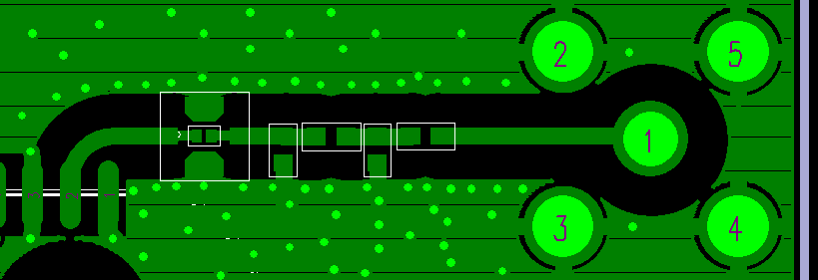

picture32: PCB trace reference

# Electrical parameters

## Limit parameters

The following table shows the state of the absolute maximum value under abnormal working conditions. Exceeding these limit values ​​may cause permanent damage to the module.

Table 37：Limit parameters

|  |  |  |  |  |
| --- | --- | --- | --- | --- |
| parameter | Minimum | Typical value | Max | unit |
| VBAT pin limit voltage | -0.5 | - | 4.8 | V |
| VBUS pin limit voltage | -0.5 | - | 5.4 | V |
| IO port limit voltage:  GPIO, UART | -0.3 | - | 2.0 | V |
| IO port limit voltage:  USIM | -0.3 | - | 2.0 | V |
| -0.3 | - | 3.9 | V |
| PWRKEY, RESET | -0.3 | - | 4.8 | V |

## Normal working conditions

Table 38：The recommended working voltage of the module

|  |  |  |  |  |
| --- | --- | --- | --- | --- |
| **parameter** | **Minimum** | **Typical value** | **Max** | **unit** |
| VBAT pin operating voltage | 3.4 | 3.8 | 4.2 | V |
| VBUS pin operating voltage | 3.0 | 5.0 | 5.2 | V |

Table 39：1.8V digital interface characteristics

|  |  |  |  |  |  |
| --- | --- | --- | --- | --- | --- |
| parameter | describe | Minimum | Typical value | Max | unit |
| VIH | Input high level voltage | VCC*0.7 | 1.8 | VCC+0.2 | V |
| VIL | Input low-level voltage | -0.3 | 0 | VCC*0.3 | V |
| VOH | Output high level voltage | VCC-0.2 | - | - | V |
| VOL | Output low-level voltage | 0 | - | 0.2 | V |
| IOH | High-level output current (when the module is not equipped with a pull-down resistor) | - | - | 13 | mA |
| IOL | Low-level output current (when the module is not equipped with a pull-up resistor) | - | - | 13 | mA |
| IIH | High-level input current (when the module is not equipped with a pull-down resistor) | - | - | 10 | uA |
| IIL | Low-level input current (when the module is not equipped with a pull-up resistor) | -10 | - | - | uA |

**※pay attention**

|  |
| --- |
| The above parameters apply to: GPIO, I2C, UART and USB_BOOT. |

Table 40: Module operating temperature

|  |  |  |  |  |
| --- | --- | --- | --- | --- |
| **parameter** | **Minimum** | **Typical value** | **Max** | **unit** |
| Normal working temperature | -30 | 25 | 80 | °C |
| Extended operating temperature | -40 | 25 | 85 | °C |
| storage temperature | -45 | 25 | 90 | °C |

**※pay attention**

|  |
| --- |
| When working at extended operating temperature, the module's RF specifications may not meet the 3GPP specifications. |

## Operating mode

### Working mode definition

The following table briefly introduces the various working modes that will be mentioned in the following chapters.

Table 41: Working mode definition

|  |  |  |
| --- | --- | --- |
| **Mode function** | | **definition** |
| Normal working mode | LTE sleep | In this state, the current consumption of the module will be minimized, and the module can still receive paging messages and SMS. |
| LTE idle | The software runs normally, the module has been registered on the network, and can send and receive data at any time. |
| LTE call | Two users are connected. In this case, the power consumption of the module is related to the network and the configuration of the module. |
| LTE standby | The module is ready for data transmission at any time, but it is not currently sending or receiving data. In this case, power consumption depends on network conditions and configuration. |
| LTE data transmission | The data is being transferred. In this case, the power consumption depends on the network conditions (for example: power control level), the data rate of the uplink and downlink data links, and the network configuration (for example: using a multi-slot configuration). |
| Minimal function mode | | In the case of uninterrupted power, you can use "AT+CFUN=0" command configures the module to the minimum function mode. under these circumstances, The RF part and the USIM card part do not work, but the serial port and USB can still be used, and the power consumption is lower than in normal working mode. |
| Flight mode | | In the case of uninterrupted power, use The "AT+CFUN=4" command or pull down the FLIGHTMODE pin can configure the module to flight mode. In this case, the RF part does not work, but the serial port and USB can still be used, and the power consumption is lower than in the normal working mode. |
| Shutdown mode | | pass "The A7672X module can be turned off by the AT+CPOF" command or pull down the PWRKEY pin. At this time, all power supplies inside the module are turned off and the software stops running. The serial port and USB are unavailable. |

### Sleep mode

In sleep mode, the current consumption of the module will be reduced to a minimum, but the module can still receive paging messages and SMS.

When the module meets the following software and hardware conditions, the A7672X module can automatically enter the sleep mode:

●UART conditions

●USB conditions

●Software setting conditions

For more information about sleep mode, please refer to document [24].

### Function mode

You can pass the command "AT+CFUN=<fun>" sets the module to this mode. This command provides three options for setting different functions.

●AT+CFUN=0: minimum function mode;

●AT+CFUN=1: Full function mode (default);

●AT+CFUN=4: Flight mode.

After setting "AT+CFUN=0", the module enters the minimum function mode, turning off the radio frequency function and the function of the USIM card. In this case, the serial port and USB can still be used, but the functions related to the radio frequency and USIM card and some AT commands cannot be used.

After setting "AT+CFUN=4", the module enters the flight mode and turns off the radio frequency function. In this case, the serial port and USB of the module can still be used, but the functions related to the radio frequency and some AT commands cannot be used.

When the module enters the minimum function mode or enters the flight mode, it can be returned to the full function mode through the command "AT+CFUN=1".

For more information about "AT+CFUN" command, please refer to document [1].

## Current consumption

Table 42：VBAT current consumption (VBAT=3.8V)

|  |  |
| --- | --- |
| **GSM sleep/idle** | |
| GSM/GPRS current consumption  (Without USB connection) | Sleep mode @BS_PA_MFRMS=2 Typical value: TBD  Idle mode @BS_PA_MFRMS=2 Typical value: TBD |

|  |  |
| --- | --- |
| **LTE sleep/idle** | |
| Current consumption under CFUN=0, CSCLK=1 | <2mA |
| LTE supply current  (Without USB connection) | Sleep mode @DRX=0.32S Typical value: TBD  Idle mode @DRX=0.32S Typical value: TBD |

|  |  |
| --- | --- |
| **GSM call** | |
| EGSM 900 | @Power level #5 Typical value: TBD |
| DCS1800 | @Power level #0 Typical value: TBD |
| **GPRS data transmission** | |
| EGSM 900 (1 receiving, 4 sending) | @Power level #5 Typical value: TBD |
| DCS1800 (1 receiving, 4 sending) | @Power level #0 Typical value: TBD |
| EGSM 900 (3 receiving, 2 sending) | @Power level #5 Typical value: TBD |
| DCS1800 (3 receiving, 2 sending) | @Power level #0 Typical value: TBD |
| **EDGE data transmission** | |
| EGSM 900 (1 receiving, 4 sending) | @Power level #8 Typical value: TBD |
| DCS1800 (1 receiving, 4 sending) | @Power level #2 Typical value: TBD |
| EGSM 900 (3 receiving, 2 sending) | @Power level #8 Typical value: TBD |
| DCS1800 (3 receiving, 2 sending) | @Power level #2 Typical value: TBD |

|  |  |
| --- | --- |
| **LTE sleep/idle** | |
| Current consumption under CFUN=0, CSCLK=1 | <2mA |
| LTE supply current  (Without USB connection) | Sleep mode @DRX=0.32S Typical value: TBD  Idle mode @DRX=0.32S Typical value: TBD |
| **LTE data transmission** | |
| LTE-FDD B1 | @5MHz 23.0dBm typical value:600mA  @10MHz 23.0dBm typical value:600mA  @20MHz 23.0dBm typical value:600mA |
| LTE-FDD B3 | @5MHz 23.0dBm typical value:600mA  @10MHz 23.0dBm typical value:600mA  @20MHz23.0dBm Typical value:600mA |
| LTE-FDD B5 | @5MHz23.0dBm Typical value:580mA  @10MHz 23.0dBm typical value:580mA |
| LTE-FDD B8 | @5MHz23.0dBm Typical value:600mA  @10MHz 23.0dBm typical value:600mA |
| LTE-TDD B34 | @5MHz 23.0dBm typical value: 260mA  @20MHz 23.0dBm typical value: 260mA |
| LTE-TDD B38 | @5MHz 23.0dBm typical value: 280mA  @20MHz 23.0dBm typical value: 280mA |
| LTE-TDD B39 | @5MHz 23.0dBm typical value: 250mA  @20MHz 23.0dBm typical value: 250mA |
| LTE-TDD B40 | @5MHz 23.0dBm typical value: 250mA  @20MHz 23.0dBm typical value: 250mA |
| LTE-TDD B41 | @5MHz 23.0dBm typical value: 280mA  @20MHz 23.0dBm typical value: 280mA |

## Static Protection

The A7672X module is an electrostatic sensitive device. Therefore, users must pay attention to electrostatic protection when producing, assembling and operating the module. The electrostatic performance parameters of the module are as follows:

Table 43：ESD performance parameters (temperature: 25℃, humidity: 45%)

|  |  |  |
| --- | --- | --- |
| **Pin** | **Contact discharge** | **Air discharge** |
| VBAT, GND | +/-5K | +/-10K |
| Antenna port | +/-5K | +/-10K |
| USB interface | +/-4K | +/-8K |
| UART interface | +/-4K | +/-6K |
| Other pins | +/-1K | +/-2K |

**※pay attention**

|  |
| --- |
| Test condition: The module is on the SIMCom development board (the development board with necessaryESDProtection device) |

# Patch production

## Top and bottom views of the module

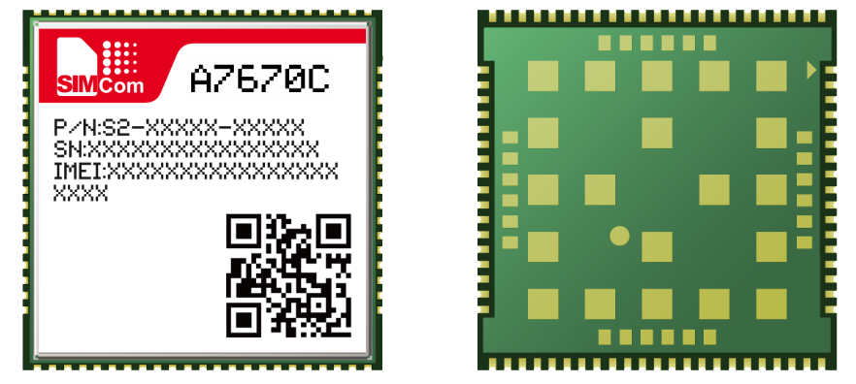

picture33: Top view and bottom view of the module

**※pay attention**

|  |
| --- |
| The above is the module design renderings for reference, and the actual appearance is subject to the actual product. |

## Label Information

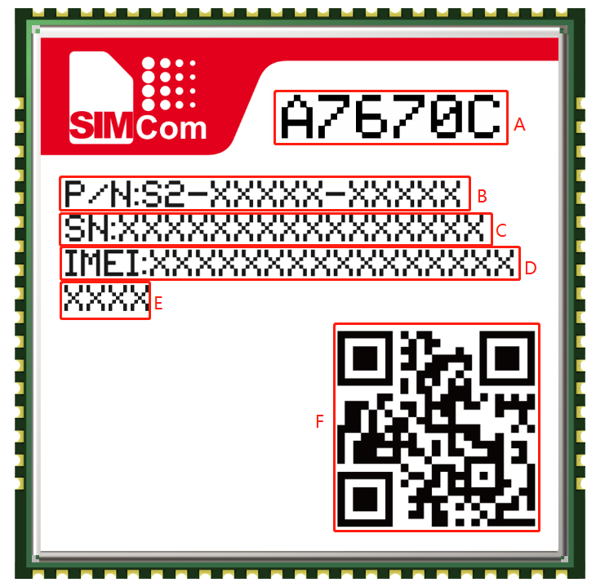

picture34:Label Information

Table 44: Module information description

|  |  |
| --- | --- |
| **Item** | **describe** |
| A | Project name |
| B | Module P/N number |
| C | Module SN |
| D | Module IMEI number |
| E | Module serial number |
| F | QR code |

## Typical welding furnace temperature curve

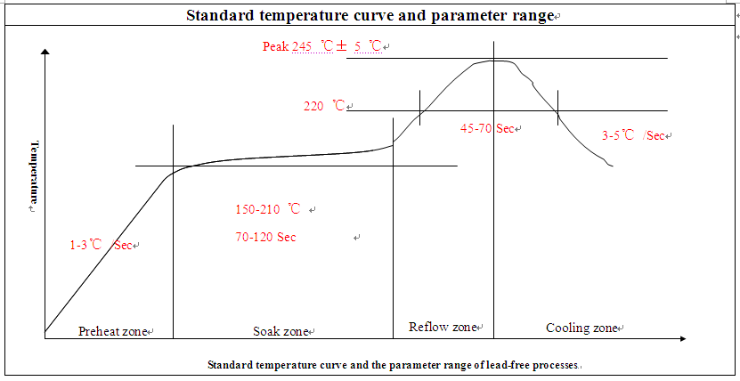

picture35：Recommended soldering furnace temperature curve diagram (lead-free process)

**※pay attention**

|  |
| --- |
| Please refer to the document [21] for more introduction to the second patch. |

## Humidity sensitive characteristics

The humidity sensitivity of the A7672X module is level 3.

If any of the following two conditions are met, the A7672X module should be fully baked before reflow soldering, otherwise the module may cause permanent damage during the reflow soldering process.

After unpacking or vacuum packaging is damaged and air leaks, the A7672X module needs to be SMT patched within 168 hours under environmental conditions of temperature <30 degrees and relative humidity <60%. If the above conditions are not met, bake is required.

If the vacuum package is not opened, but the shelf life has expired, baking is also required.

Baking conditions: 192 hours of baking under the conditions of humidity less than 5% and temperature of 40+5/-0°C; 72 hours of baking under conditions of humidity less than 5% and temperature of 85+5/-0°C ( If using a tray, please pay attention to whether the tray is resistant to thermal deformation).

Table 45：Module humidity sensitivity characteristics

|  |  |
| --- | --- |
| **grade** | **Floor life (factory environment≦+30°C/60%RH)** |
| 1 | Guaranteed indefinitely in the environment≦+30°C/85% RH condition |
| 2 | 1 year |
| 2a | 4 weeks |
| 3 | 168 hours |
| 4 | 72 hours |
| 5 | 48 hours |
| 5a | 24 hours |
| 6 | Use it after forced baking. After baking, the module must be patched within the time limit specified on the label. |

**※pay attention**

|  |
| --- |
| Product handling, storage, and processing must be followed IPC/JEDEC J-STD-033. |

# Package

The module supports pallet packaging.

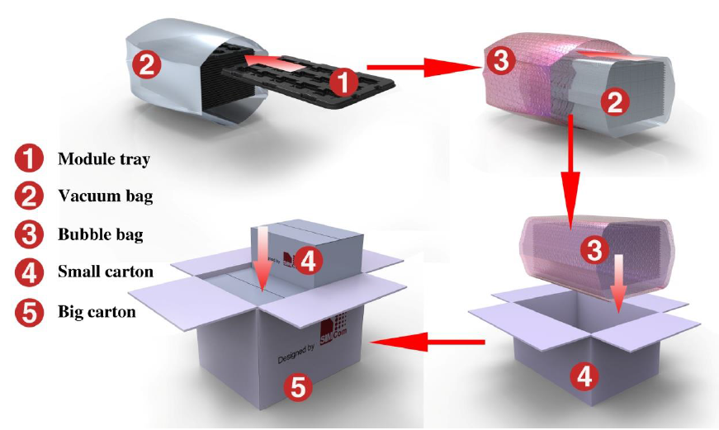

picture36：Schematic diagram of module packaging

The following is the size drawing of the module tray:

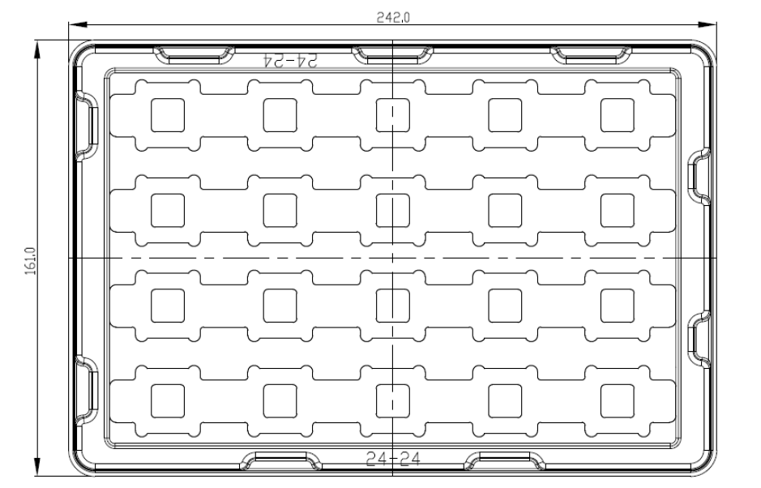

picture37：Tray size chart

Table 46: Pallet size information

|  |  |  |
| --- | --- | --- |
| **Pallet length (±3mm)** | **Tray width (±3mm)** | **Number of standard packages** |
| 242.0 | 161.0 | 20 |

The following is the size drawing of the small carton pallet:

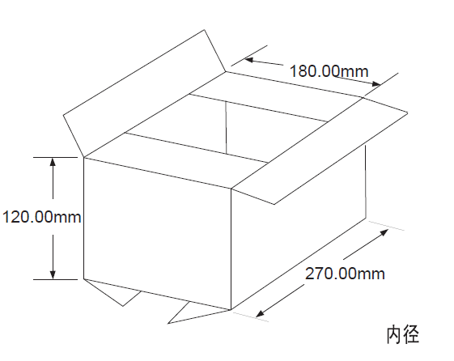

picture38：Small cartoon box size chart

Table 47：Small cartoon box size information

|  |  |  |  |
| --- | --- | --- | --- |
| **Box length (±10mm)** | **Box width (±10mm)** | **Box height (±10mm)** | **Number of standard packages** |
| 270 | 180 | 120 | 20*20=400 |

The following is the size drawing of the Big carton pallet:

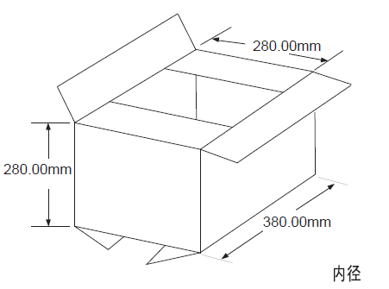

picture39：Diagram of large cartoon box

Table 48：The size information of the big cartoon box

|  |  |  |  |
| --- | --- | --- | --- |
| **Box length (±10mm)** | **Box width (±10mm)** | **Box height (±10mm)** | **Number of standard packages** |
| 380 | 280 | 280 | 400*4=1600 |

# appendix

## Encoding method and maximum data rate

Table 49: Coding method and maximum data rate

|  |  |  |  |
| --- | --- | --- | --- |
| **Channel definition (GPRS/EDGE)** | | | |
| **Slot class** | **DL slot number** | **UL slot number** | **Active slot number** |
| 1 | 1 | 1 | 2 |
| 2 | 2 | 1 | 3 |
| 3 | 2 | 2 | 3 |
| 4 | 3 | 1 | 4 |
| 5 | 2 | 2 | 4 |
| 6 | 3 | 2 | 4 |
| 7 | 3 | 3 | 4 |
| 8 | 4 | 1 | 5 |
| 9 | 3 | 2 | 5 |
| 10 | 4 | 2 | 5 |
| 11 | 4 | 3 | 5 |
| 12 | 4 | 4 | 5 |
| **LTE-FDD device category**  **(Downlink)** | **Max data rate(peak)** | | **Modulation type** |
| Category 1 | 10Mbps | | QPSK/16QAM/64QAM |
| Category 2 | 50Mbps | | QPSK/16QAM/64QAM |
| Category 3 | 100Mbps | | QPSK/16QAM/64QAM |
| Category 4 | 150Mbps | | QPSK/16QAM/64QAM |
| **LTE-FDD device category**  **(Uplink)** | **Max data rate(peak)** | | **Modulation type** |
| Category 1 | 5Mbps | | QPSK/16QAM |
| Category 2 | 25Mbps | | QPSK/16QAM |
| Category 3 | 50Mbps | | QPSK/16QAM |
| Category 4 | 50Mbps | | QPSK/16QAM |

## Reference documents

Table 50: Reference documents

|  |  |  |
| --- | --- | --- |
| **SNo** | **file name** | **Annotation** |
| [1] | A7600 Series_AT Command Manual | AT Command Manual |
| [2] | ITU-T Draft new recommendationV.25ter | Serial asynchronous automatic dialing and control |
| [3] | GSM 07.07 | Digital cellular telecommunications (Phase 2+); AT command set for GSM Mobile Equipment (ME) |
| [4] | GSM 07.10 | Support GSM 07.10 multiplexing protocol |
| [5] | GSM 07.05 | Digital cellular telecommunications (Phase 2+); Use of Data Terminal Equipment – ​​Data Circuit terminating Equipment (DTE – DCE) interface for Short Message Service (SMS) and Cell Broadcast Service (CBS) |
| [6] | GSM 11.14 | Digital cellular telecommunications system (Phase 2+); Specification of the USIM Application Toolkit for the Subscriber Identity Module – Mobile Equipment (USIM – ME) interface |
| [7] | GSM 11.11 | Digital cellular telecommunications system (Phase 2+); Specification of the Subscriber Identity Module – Mobile Equipment (USIM – ME) interface |
| [8] | GSM 03.38 | Digital cellular telecommunications system (Phase 2+); Alphabets and language-specific information |
| [9] | GSM 11.10 | Digital cellular telecommunications system (Phase 2); Mobile Station (MS) conformance specification; Part 1: Conformance specification |
| [10] | 3GPP TS 51.010-1 | Digital cellular telecommunications system (Release 5); Mobile Station (MS) conformance specification |
| [11] | 3GPP TS 34.124 | Electromagnetic CompatibilityEMC) for mobile terminals and ancillary equipment. |
| [12] | 3GPP TS 34.121 | Electromagnetic CompatibilityEMC) for mobile terminals and ancillary equipment. |
| [13] | 3GPP TS 34.123-1 | Technical Specification Group Radio Access Network; Terminal conformance specification; Radio transmission and reception (FDD) |
| [14] | 3GPP TS 34.123-3 | User Equipment (UE) conformance specification; Part 3: Abstract Test Suites. |
| [15] | EN 301 908-02 V2.2.1 | Electromagnetic compatibility and Radio spectrum Matters  (ERM); Base Stations (BS) and User Equipment (UE) for  IMT-2000. Third Generation cellular networks; Part 2:  Harmonized EN for IMT-2000, CDMA Direct Spread  (UTRA FDD) (UE) covering essential requirements of article  3.2 of the R&TTE Directive |
| [16] | EN 301 489-24 V1.2.1 | Electromagnetic compatibility and Radio Spectrum Matters (ERM); Electromagnetic Compatibility (EMC) standard for radio equipment and services; Part 24: Specific conditions for IMT-2000 CDMA Direct Spread (UTRA) for Mobile and portable (UE) radio and ancillary equipment |
| [17] | IEC/EN60950-1(2001) | Safety of information technology equipment (2000) |
| [18] | 3GPP TS 51.010-1 | Digital cellular telecommunications system (Release 5); Mobile Station (MS) conformance specification |
| [19] | GCF-CC V3.23.1 | Global Certification Forum-Certification Criteria |
| [20] | 2002/95/EC | Directive of the European Parliament and of the Council of 27 January 2003 on the restriction of the use of certain hazardous substances in electrical and electronic equipment (RoHS) |
| [21] | Module secondary-SMT-UGD-V1.xx | Module secondary SMT Guidelines |
| [22] | A7600Series_UART_Application Note_V1.xx | This document describes how to use UART interface of SIMCom modules. |
| [23] | Antenna design guidelines for diversity receiver system | Antenna design guidelines for diversity receiver system |
| [24] | A7600 Series_SleepMode_Application Note_V1.xx | Sleep Mode Application Note |
| [25] | A7600 Series_UIM HOT SWAP_Application Note_V1.00 | This document introduces UIM card detection and UIM hot swap. |

## Terminology and explanation

Table 51: Terminology and explanation

|  |  |
| --- | --- |
| **the term** | **explain** |
| ADC | Analog-to-Digital Converter |
| AMR | Adaptive Multi-Rate |
| CS | Coding Scheme |
| CSD | Circuit Switched Data |
| CTS | Clear to Send |
| DTE | Data Terminal Equipment (typically computer, terminal, printer) |
| DTR | Data Terminal Ready |
| DTX | Discontinuous Transmission |
| EFR | Enhanced Full Rate |
| EGSM | Enhanced GSM |
| ESD | Electrostatic Discharge |
| ETS | European Telecommunication Standard |
| FR | Full Rate |
| GPRS | General Packet Radio Service |
| GSM | Global Standard for Mobile Communications |
| HR | Half Rate |
| IMEI | International Mobile Equipment Identity |
| Li-ion | Lithium-Ion |
| MO | Mobile Originated |
| MS | Mobile Station (GSM engine), also referred to as TE |
| MT | Mobile Terminated |
| PAP | Password Authentication Protocol |
| PBCCH | Packet Broadcast Control Channel |
| PCB | Printed Circuit Board |
| PCL | Power Control Level |
| PCS | Personal Communication System, also referred to as GSM 1900 |
| PDU | Protocol Data Unit |
| PPP | Point-to-point protocol |
| RF | Radio Frequency |
| RMS | Root Mean Square (value) |
| RTC | Real Time Clock |
| RX | Receive Direction |
| USIM | Subscriber Identification Module |
| SMS | Short Message Service |
| TE | Terminal Equipment, also referred to as DTE |
| TX | Transmit Direction |
| UART | Universal Asynchronous Receiver & Transmitter |
| URC | Unsolicited Result Code |
| USSD | Unstructured Supplementary Service Data |
| **Phone book abbreviation** | |
| FD | USIM fix dialing phonebook |
| LD | USIM last dialing phonebook (list of numbers most recently dialed) |
| MC | Mobile Equipment list of unanswered MT calls (missed calls) |
| ON | USIM (or ME) own numbers (MSISDNs) list |
| RC | Mobile Equipment list of received calls |
| SM | USIM phonebook |
| NC | Not connect |

## safety warning

Pay attention to the following safety precautions when using or repairing any terminal or mobile phone that contains a module. The terminal equipment should inform the user of the following safety information. Otherwise, SIMCom will not bear any consequences arising from the user's failure to follow these warnings.

Table 52:safety warning

|  |  |
| --- | --- |
| **Logo** | **Require** |
|  | When in a hospital or next to medical equipment, observe the restrictions on the use of mobile phones. Please turn off the terminal or mobile phone if necessary, otherwise the medical equipment may cause misoperation due to radio frequency interference. |
|  | Turn off the wireless terminal or mobile phone before boarding. In order to prevent interference with the communication system, the use of wireless communication equipment on the aircraft is prohibited. Ignoring the above matters will violate local laws and may lead to flight accidents. |
|  | Do not use mobile terminals or cell phones in front of flammable gases. Turn off your mobile phone terminal when you are near explosive operations, chemical plants, fuel depots, or gas stations. It is very dangerous to operate a mobile terminal near any potentially explosive electrical equipment. |
|  | The mobile phone terminal receives or emits radio frequency energy when it is turned on. When it is close to TV, radio, computer or other electrical equipment, it will cause interference. |
|  | Road safety first! Do not use handheld terminals or mobile phones when driving vehicles, please use hands-free devices. Stop the car before using the handheld terminal or mobile phone. |
|  | GSM mobile phone terminals operate under radio frequency signals and cellular networks, but there is no guarantee that they can be connected under all conditions. For example, no phone bill or invalid USIM card. When you need emergency services in this situation, remember to use the emergency phone. In order to be able to make and receive calls, the mobile terminal must be turned on and be in a service area where the mobile signal is strong enough. Emergency calls are not allowed when certain network services or phone functions are in use, such as function lock and keyboard lock. Before using the emergency phone, disable these functions. Some networks require valid USIM card support. |